Spring Framework and Boot

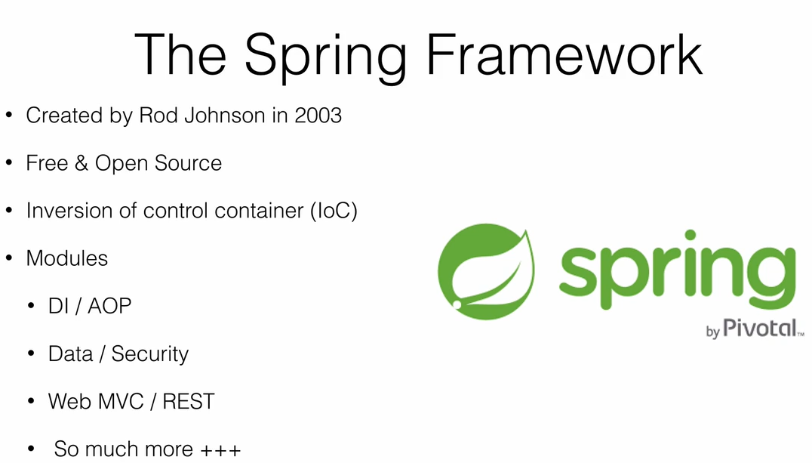

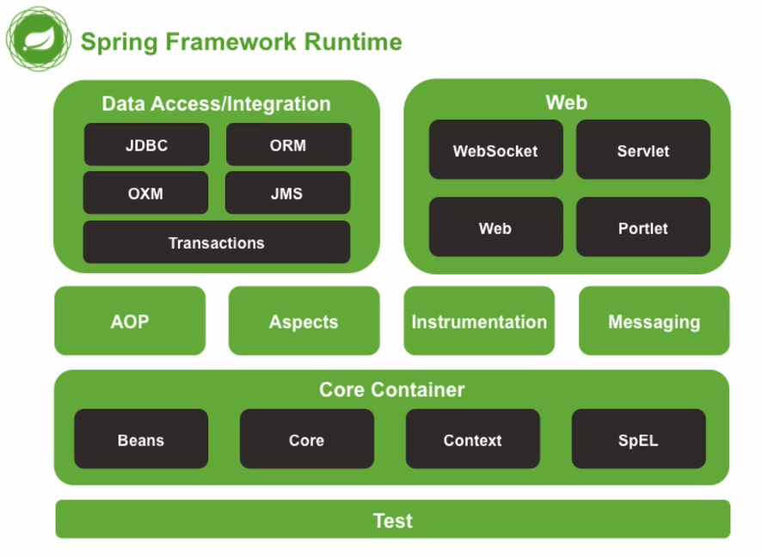

Spring IP Projects

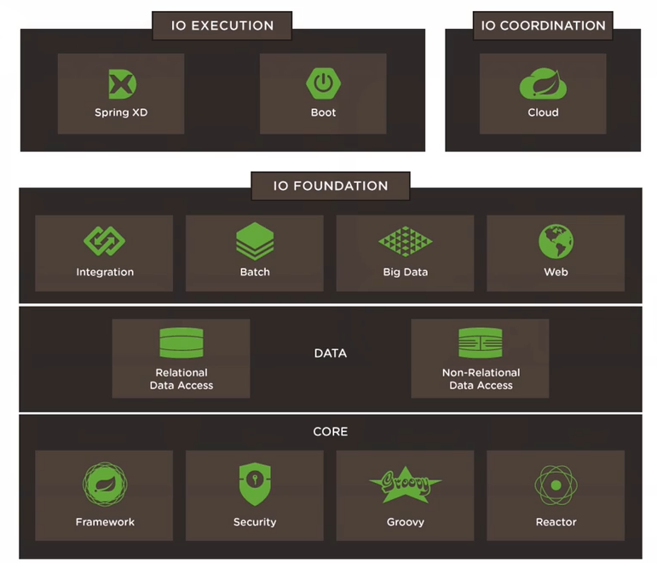

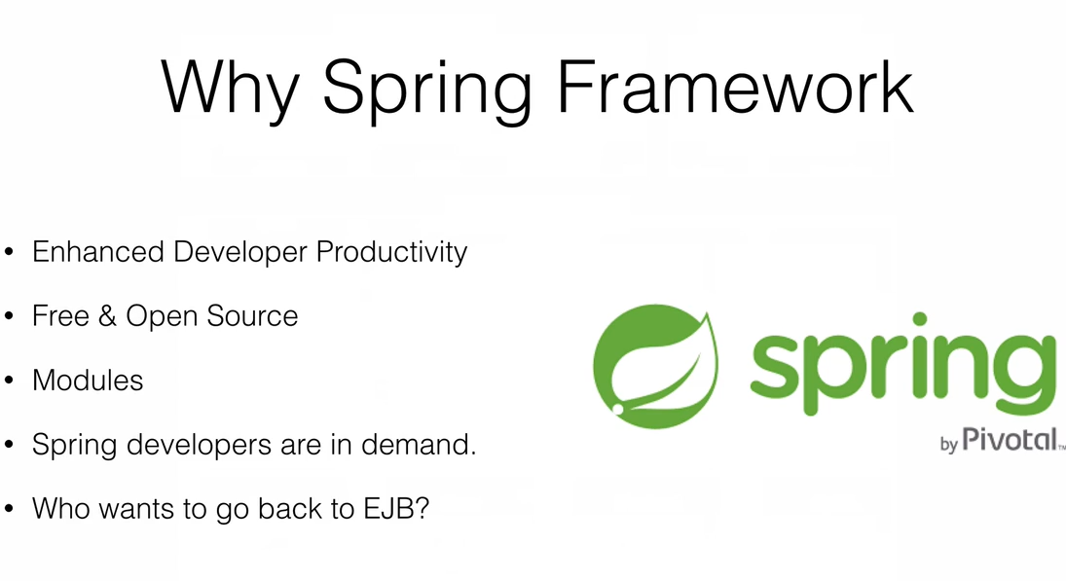

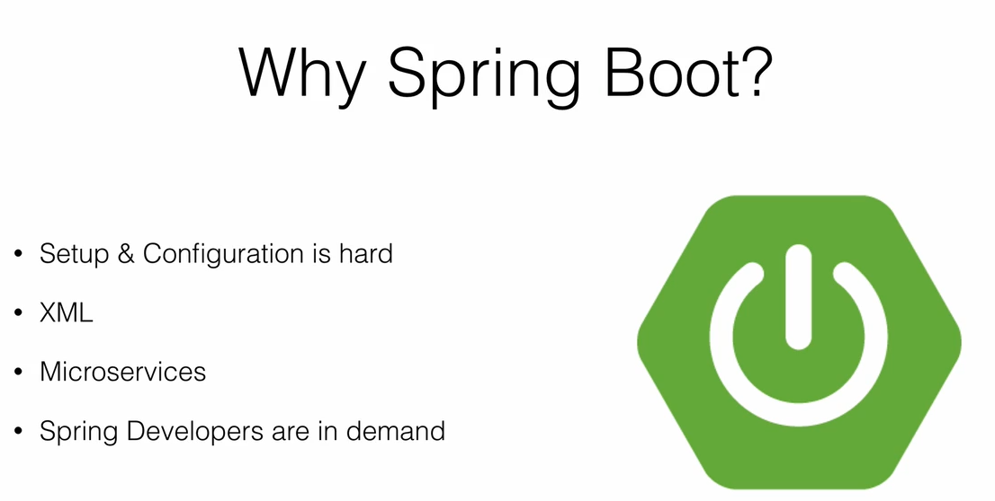

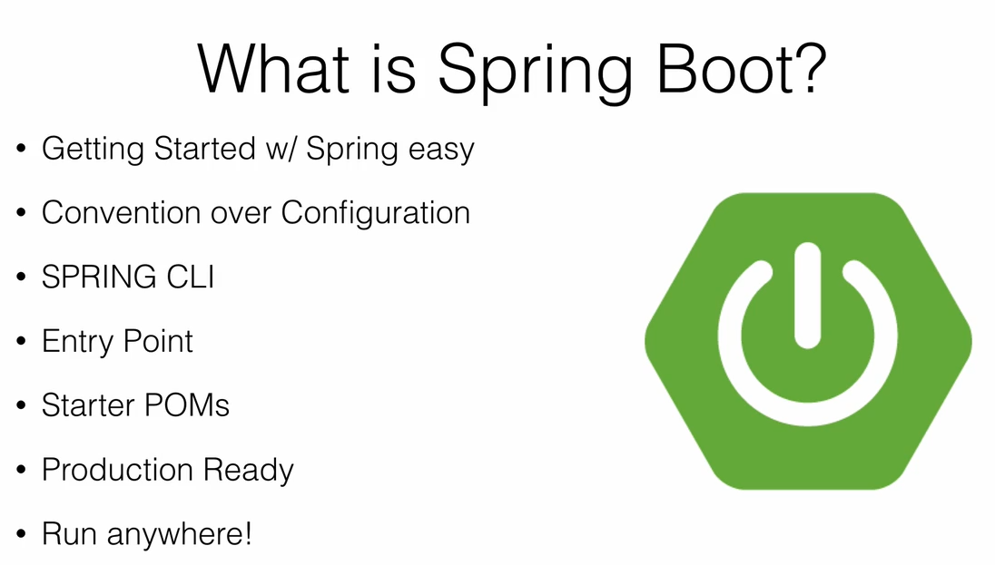

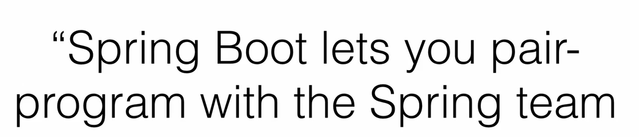

Envirnoment Setup

1 Install Java

2 Groovy install

Cmd-> groovy -v N/A

Url : <https://groovy.apache.org/download.html> => download Binary version

Extract copy folder path upto bin not including bin

SET VARIABLE : GROOVY_HOME and set folder path same like JAVA_HOME

Next in path : %GROOVY_HOME%\bin;

Cmd -> groovy -v WORKS

Another way to install groovy using installer

URL : <https://bintray.com/search?query=groovy>

Find installer and install

3 Build Tool

Maven / Gradle

- no need to install Gradle if we use spring boot

URL : <https://gradle.org/>

GRADLE_HOME set env variable

Cmd=>gradle -v

4 Spring Boot CLI (Command Line Tool)

- no need fr spring boot defently quick way to get spring application

Ways to install

1. GVM (Groovy Environment Management) / SDK Man

Download Spring Boot Cli bin

SPRING_HOME set Env Variable

Cmd=> spring

Run spring Boot application independently

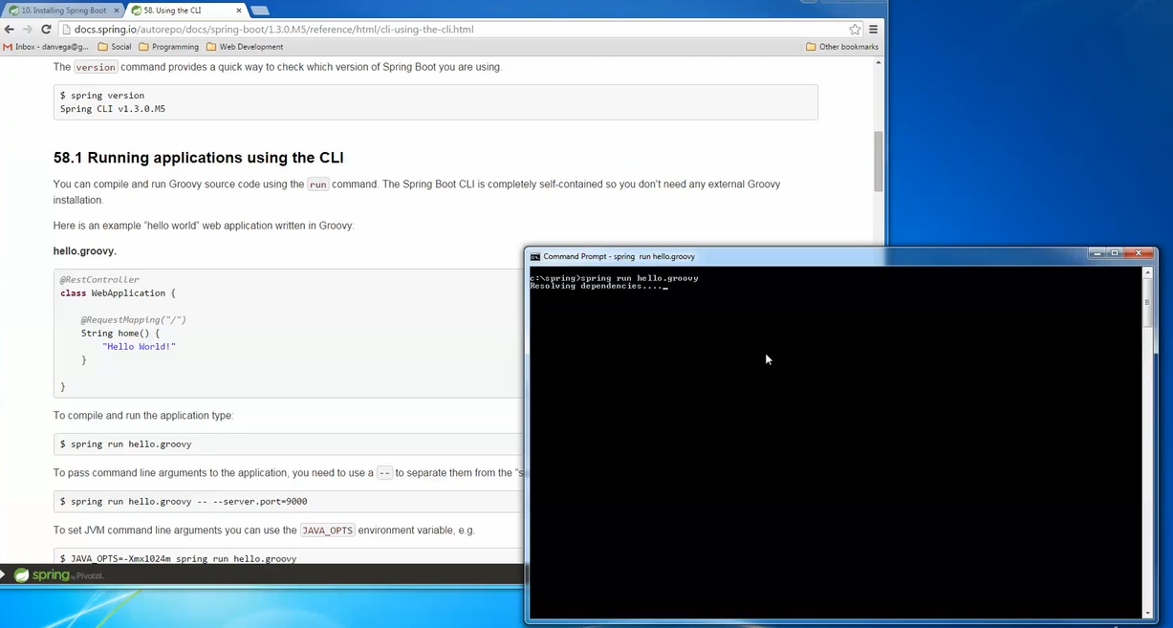

-it will run as a spring Boot Application

-hit localhost:8080 to get response

2 SDK MAN

-Handle version issues of Spring Boot Cli

Multiple version can be handled easily groovy , gradle everything

Only for Linux OS

For windows need to use cygwin cnt use directly

Sdk instal groovy

Sdk list groovy

Sdk install gradle

Sdk install springboot for spring CLI

Sdk install springboot 1.3.0.M5

Spring init -list

4 Install IntelJidea or STS or Ecplise

Creating First App

1 Can directly create java Rest controller class and execute using spring cli command

Or

2 USE spring Intializer or SPRING IO site create a workspace

Spring IO is web based tool allows to generate template project and automatically sets all dependencies according to technologies instead of configuring manually

Not only using SPring IO we can get Template project using SPring CLi we can do same

1 SPring Cli

- spring init -list

Spring init -d=web my-app

Default it will create a maven project for Gradle we can configure it

2 Curl

-curl start.spring.io

-curl <https://start.spring.io/staarter.zip> -o demo.zip

3 From IntelJ IDE

- option of Spring IO while creating new project

Java Build Tools

- build automation is act of scripting automating tasks for developers

-Automation of developers task

1. Compiling source code to binary
2. Packaging that binary code
3. Running Test
4. Deployment to other Systems

1 ANT

2 Maven

3 Gradle

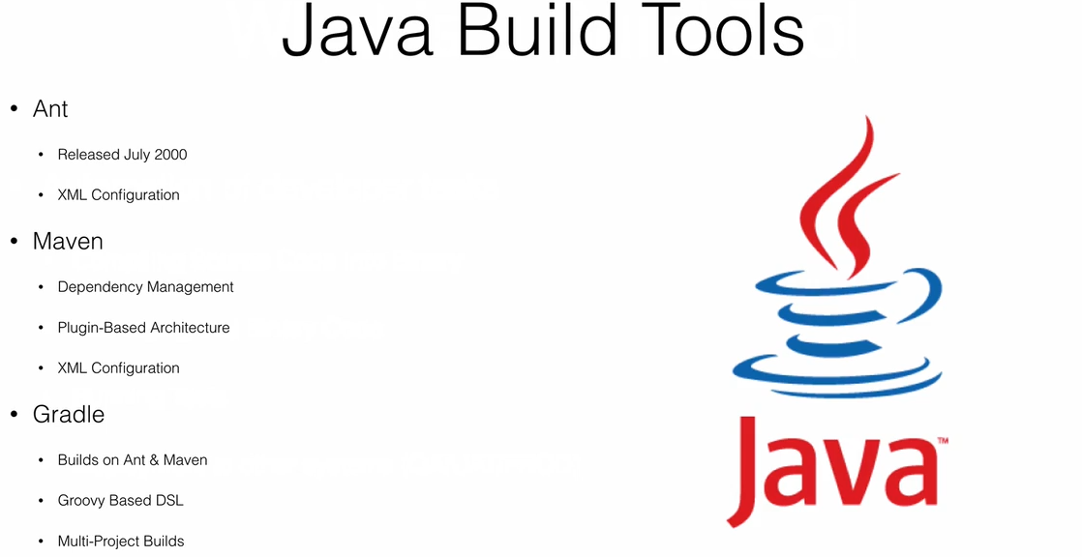

Why build tools

- why cnt we use IDE to compile my code

Ans: Lot of task in software developer should not d all day instead creating jars c=pushing source better let build tool handle it

Maven Build

Inside project form CMD

-mvn clean package

-mvn build : It wil build project

-mvn bootrun /mvn run

Gradle Build

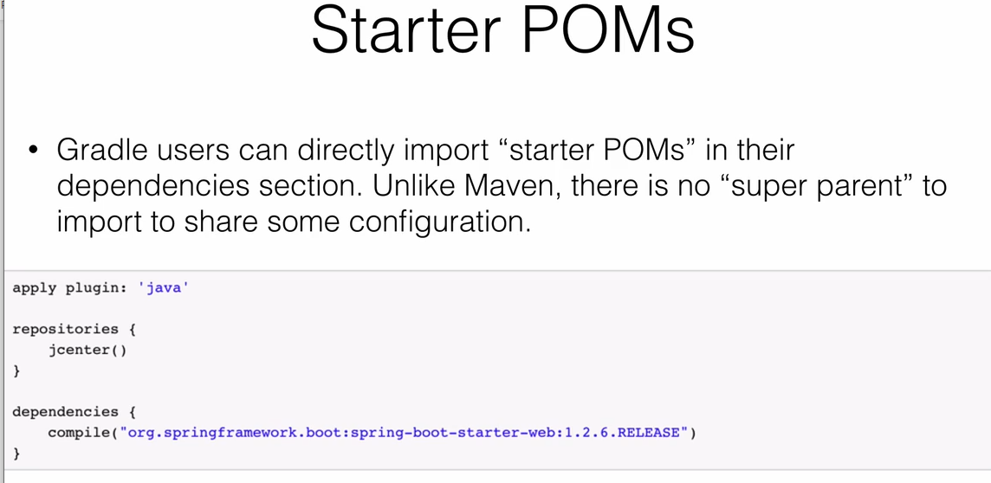

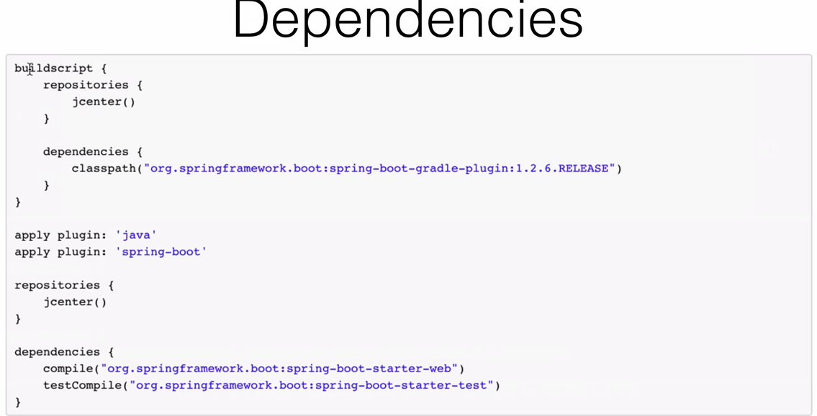

-gradlebuild : It wil build project

-gradle bootrun

Stater POM’s

-its an empty jar only purpose to provide nessary dependency to work with library

1 set of conveinent depednecy descriptor

2 aviod copy/paste

3 spring-boot-stater-*

4 create out own : acme-spring-boot-starter-*

Executable Jars

- its an archive containing our compiled class along with jar depedency which code needs to run

-cloud friendly can push it cloud

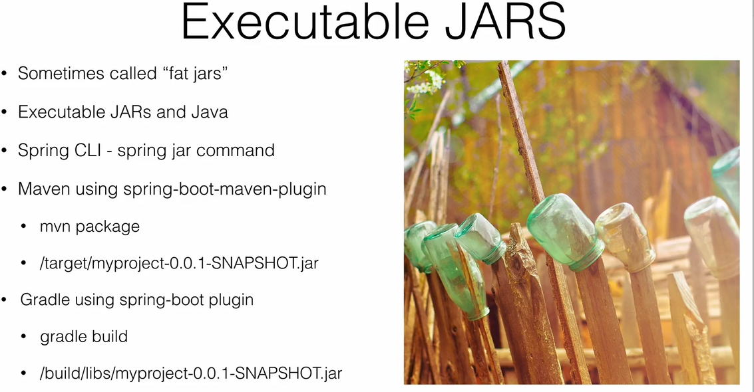

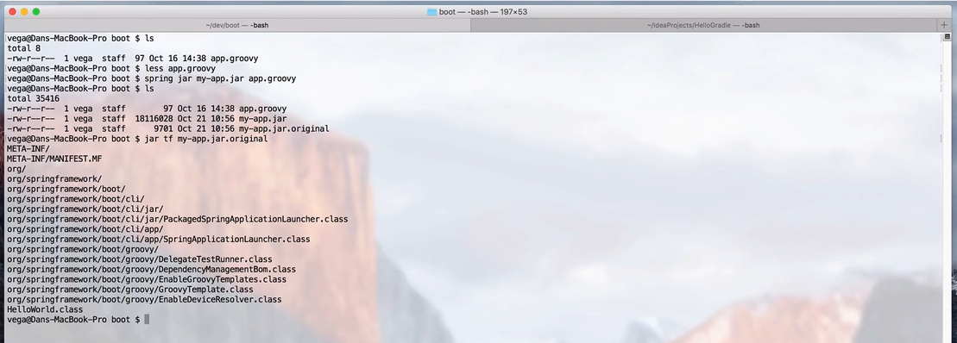

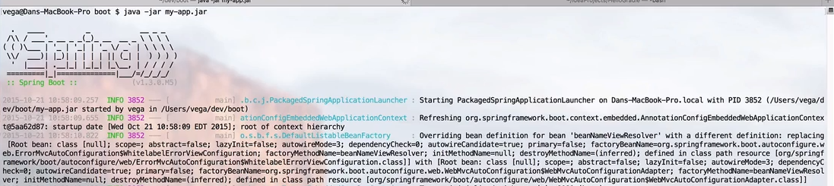

Spring Dev Tools and Live Reload

- as developer need to be more productive

- aim to impove deveolpment process time

- only in deplopemnt envirnoment it will happens onceExcutable jar File created this feature is disabled no woory about production it won work

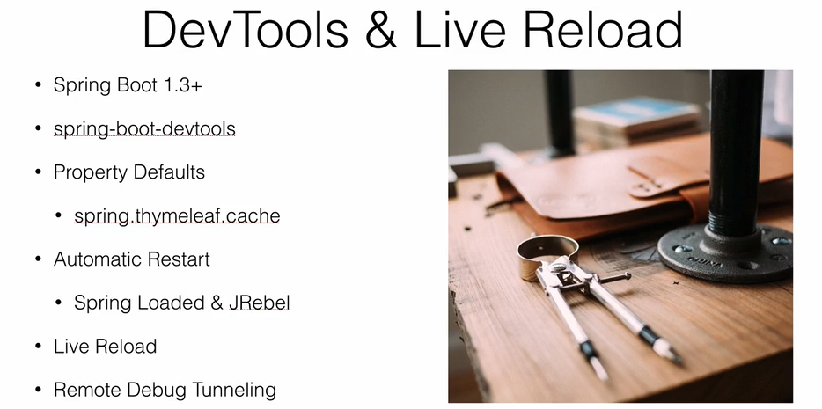

Use Live Reload Plugin _ chrome

Spring Boot Fundamentals

1 Spring Bean & DI

- back bone of applcation managed by IOC container called beans

- diffrent way to configure Container

DI :

Object defines a dependency with other objct to work with may using contrcutor , property etc.,

Container use those Depedency and create Beans

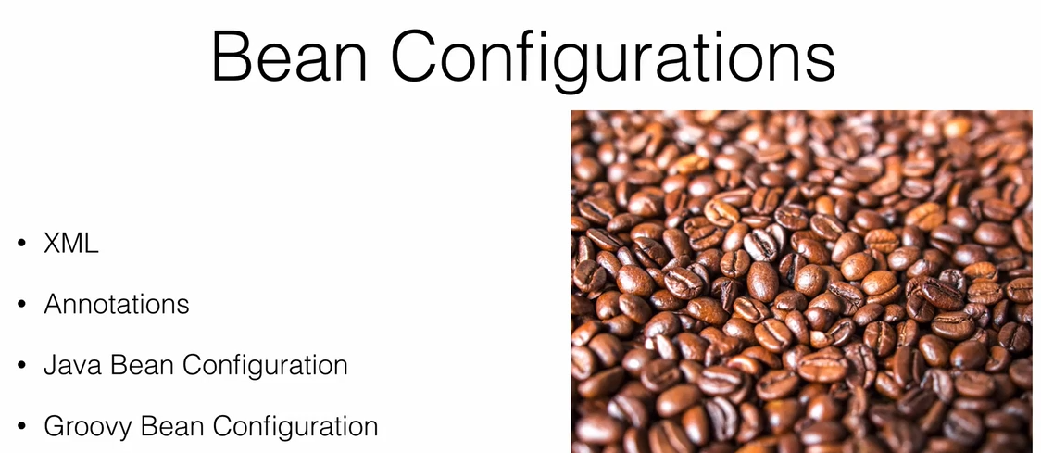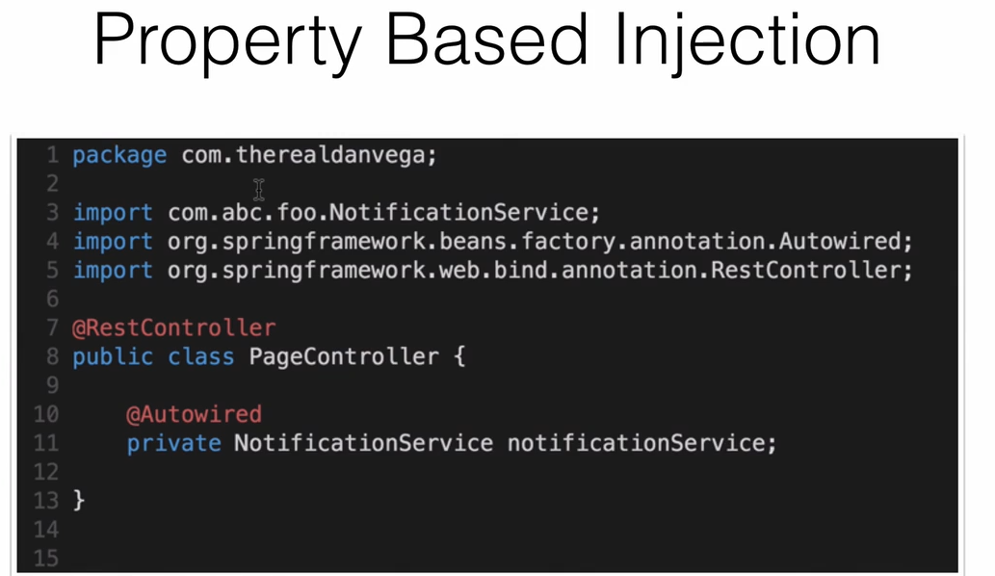

-Not a Gud Practice

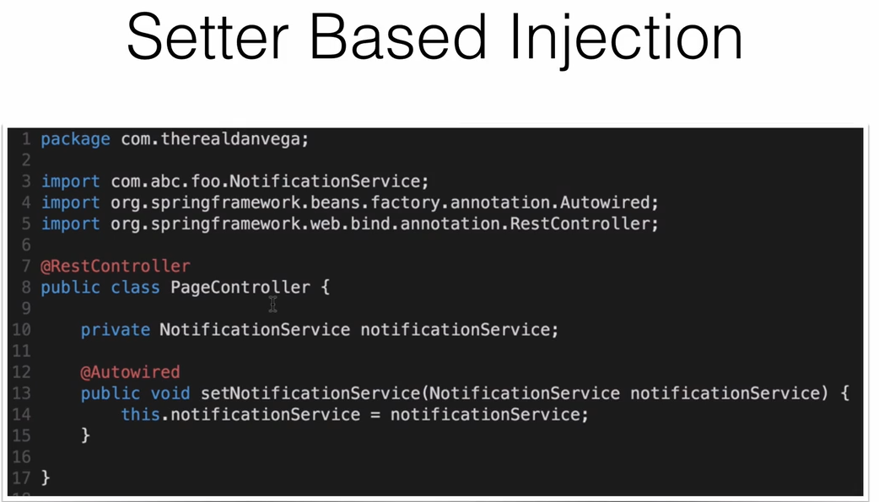

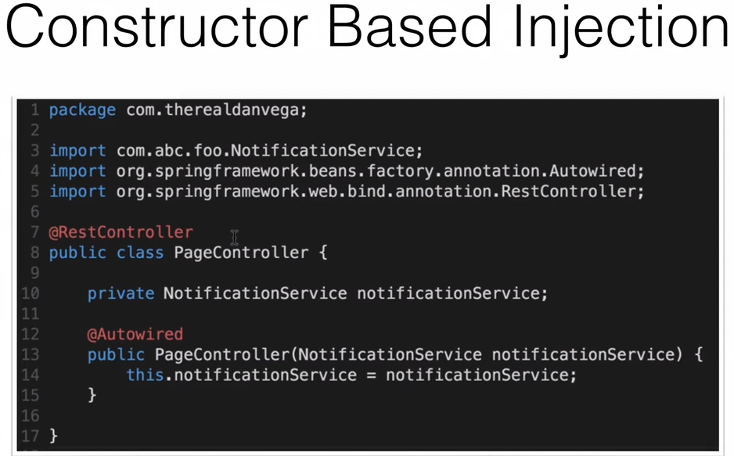

-It is good Practice

Working With Codes

In SpringBoot Main Start class

Main Applcaition class

SpringAppication.run(SpringApplication.class) ==> return applcationContext

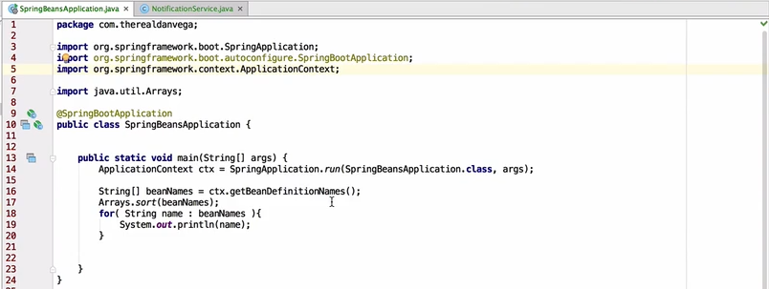

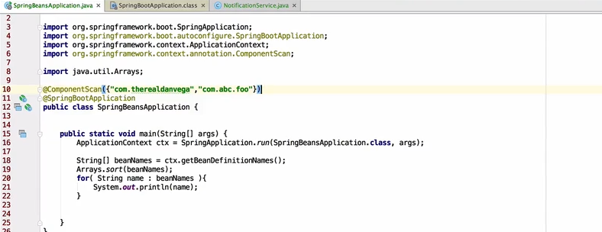

- Using @ComponetScan if the pacakge does not belong to subdirectory

- need to make user that all bean will be having deafult constructor if there is overrided constructor in Bean or else build will not happen like planned

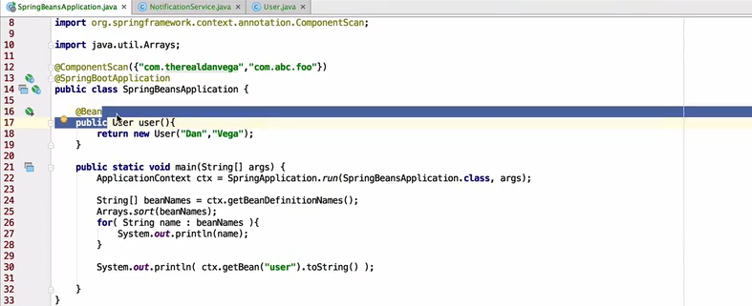

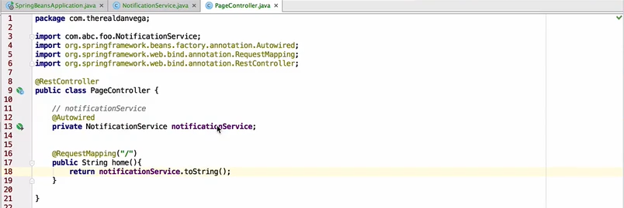

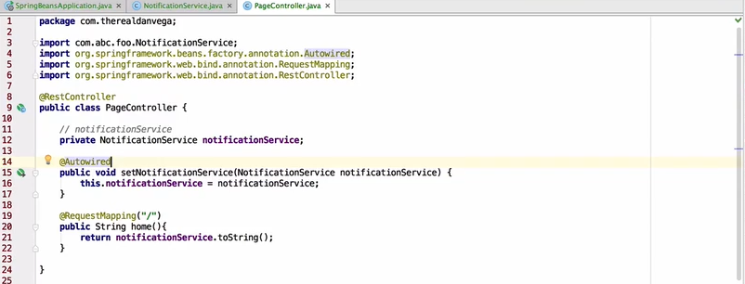

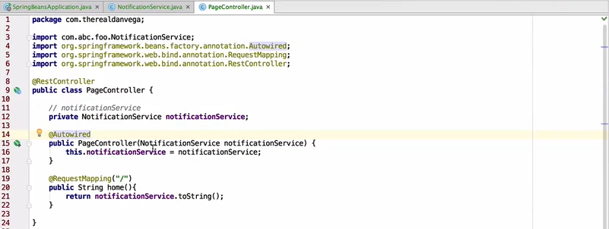

Externalized Configuration

-Spring Boot allows Externalized configuration like same application code in different envirnoment

- can use propertie files YAML files even command line to Externalize configuration

-Both application.properties and application.yml can be used at a time

-application property uses key value combination

-application.yml uses json pattern

- if both as same key then prioity will be for application.properties

- if command line is used fr settting value fr application properties key then it will take priority not property file or yml file

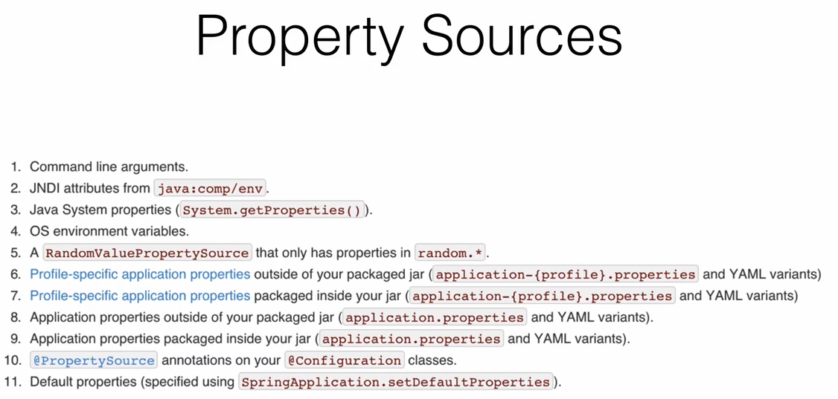

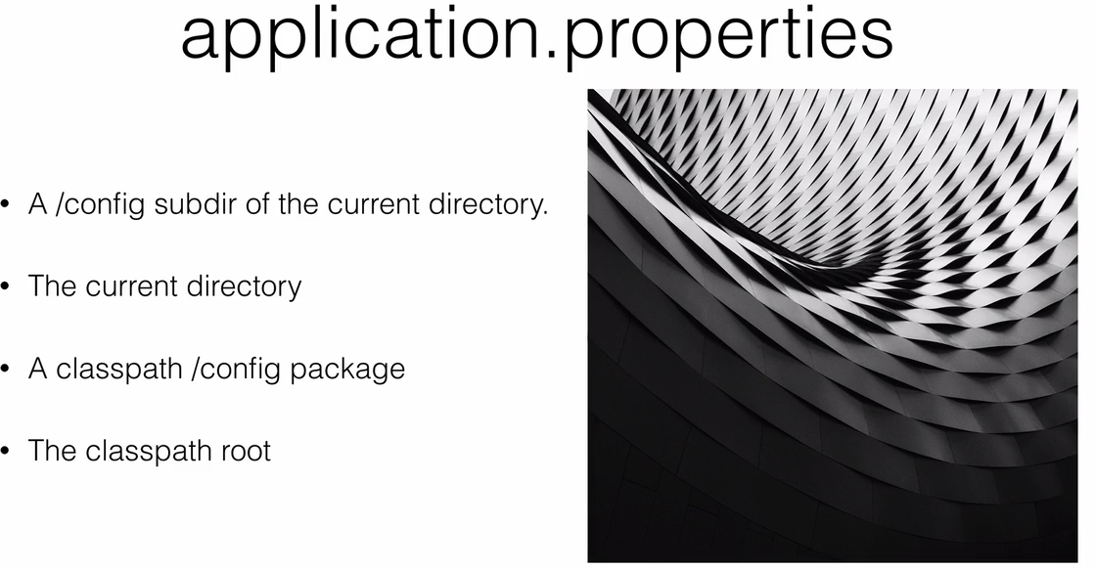

We can use YAML files instead of application properties

YAML is set of JSON data best for hierarchical configuration

Spring Application automatically support YAML as an alternative to applcaition.properties

Both applaiction.properties an YAML can be used to gether but if both as same key then applcation.properties take lead

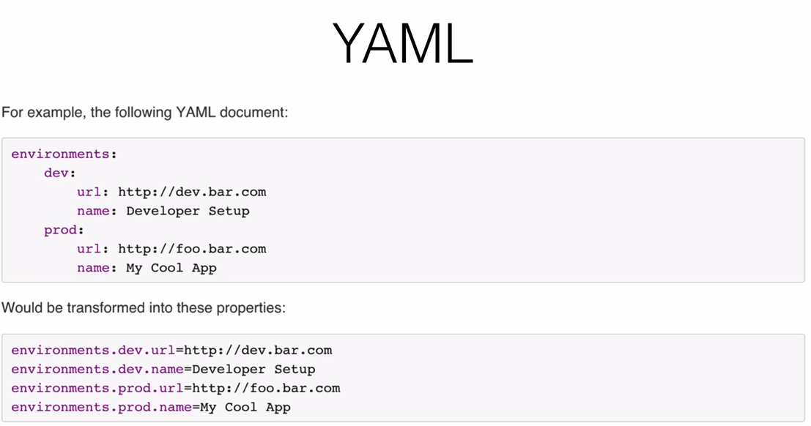

Read from application.properties file

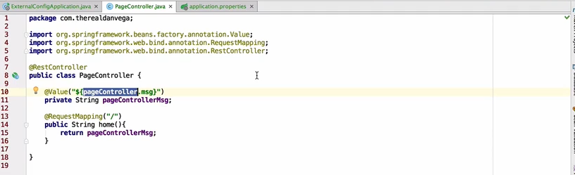

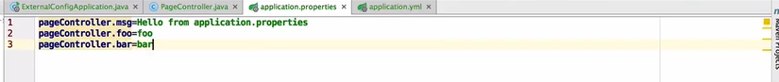

Create a new file application.yml

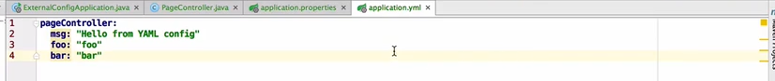

Command line Configuration

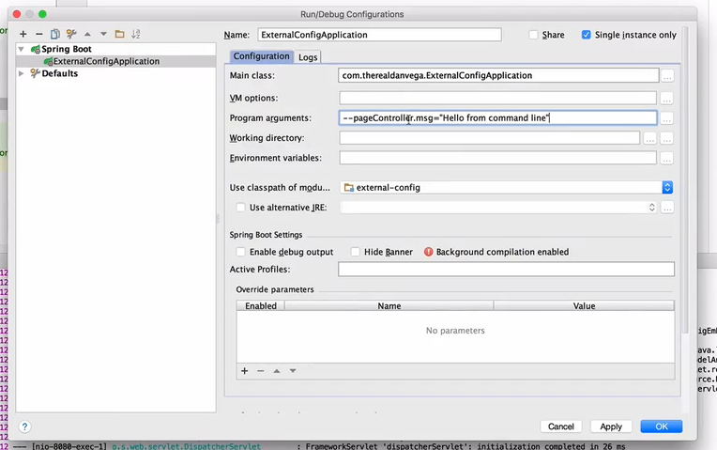

Anything start with “-- “ is property file data

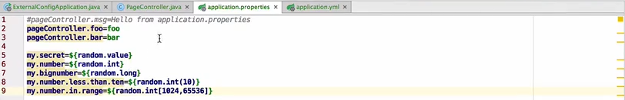

Using Placeholder in config file is supported

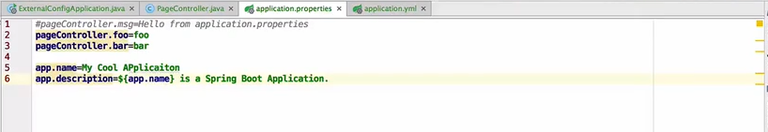

Configuration Properties

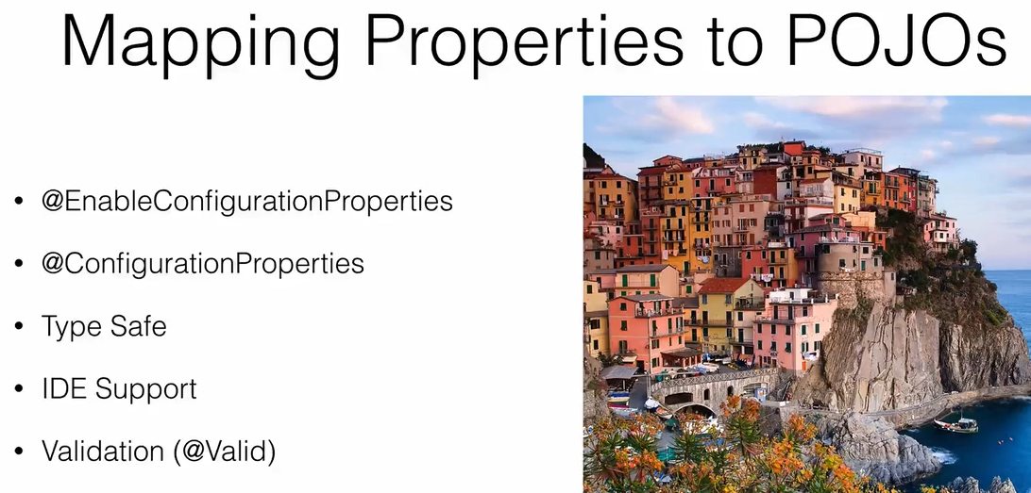

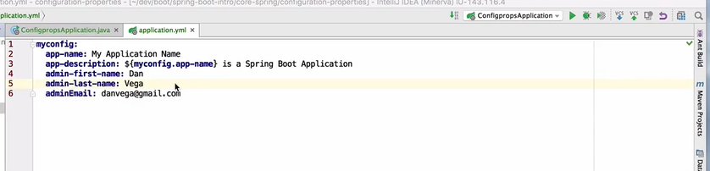

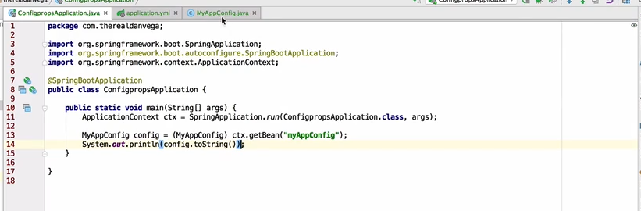

- Theres way to bind property data to an POJO/Entity class

- can use propertie file / yml file

- key can can be same as Entity.proprty with lower case or we can have some prefix entity name and property in different pattern

Developement Process

1 @EnableConfigurationProperties in Spring Main Class

2 @ConfigurationProperties(prefix=”****”) to match the propertie file prefix key

-Set @Value and full key name to one variable automatically it works for all

3 Add Depedency to automatically map the Entity from configuration.

<!-- to Auto Confguration of Prop data to entity dependency -->

<dependency>

<groupId>org.springframework.boot</groupId>

<artifactId>spring-boot-configuration-processor</artifactId>

<optional>true</optional>

</dependency>

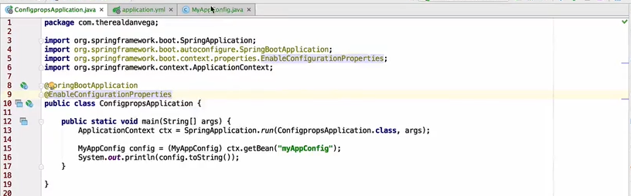

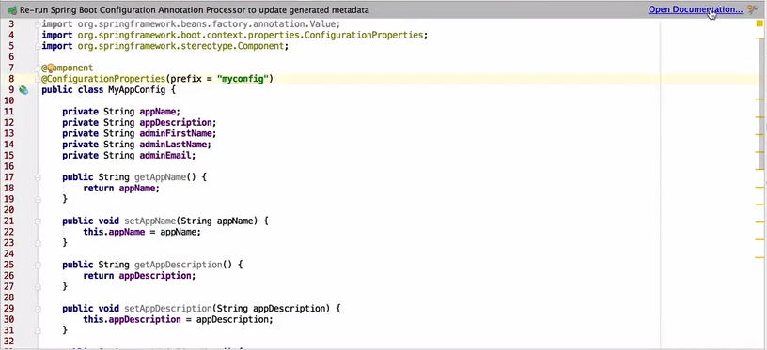

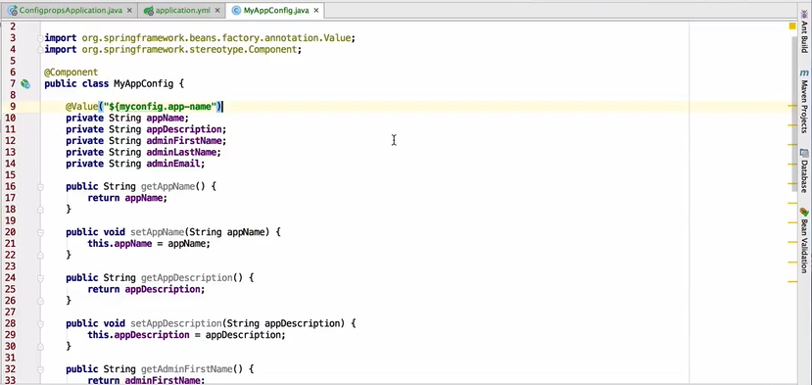

Add depedency before getting this worked

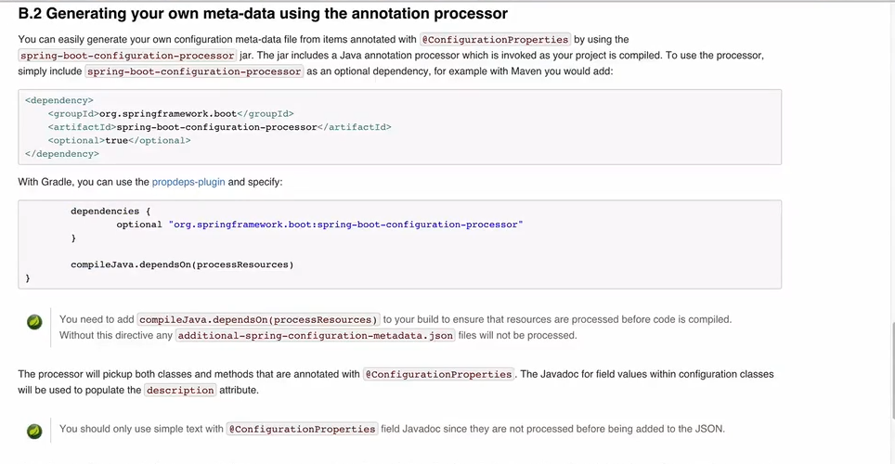

Profiles

Spring Boot Profiles: Segergate part of application configuration make it only available in certain environment

- Any @Component or @Configuration be marked with a profile to limit when it is loaded

- Like maintain local ,QA and prod environment

-Mention

spring.profiles.active=developement for dev envoiurament it can any custom name

- to use to profiles as active use comma separted prfile names

spring.profiles.active=developement,production

- application.propertieswill be used all time

-application-dev.properties only at production it will be bases on active profile

- we can set active profile In commnad line argument and that willl be taken as priority

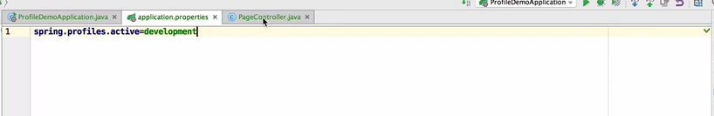

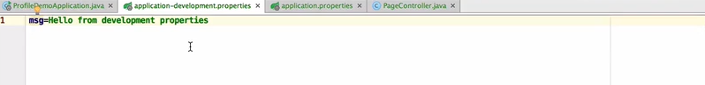

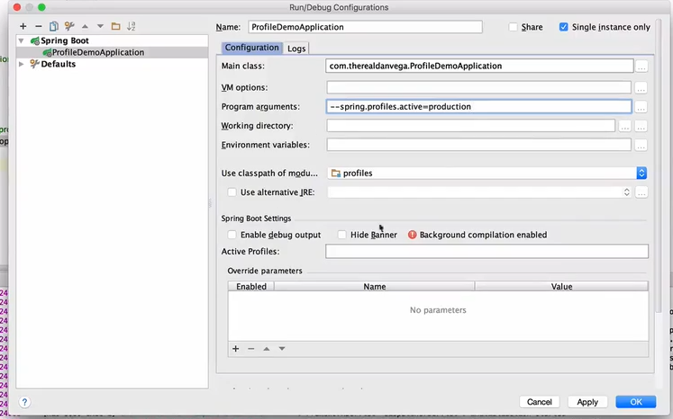

- if we are using yml file no need of extra properties file we can have dev and prod block separately

-single file connection 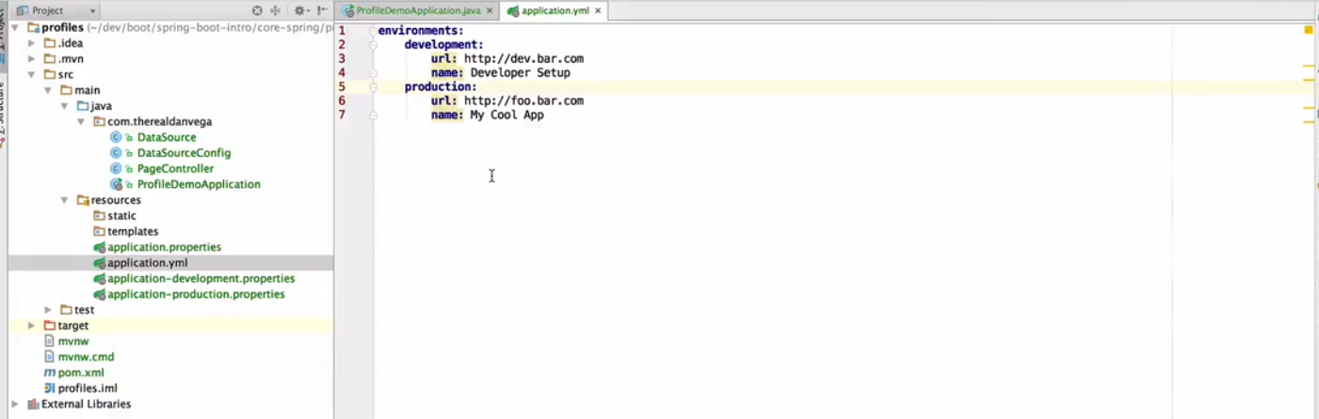

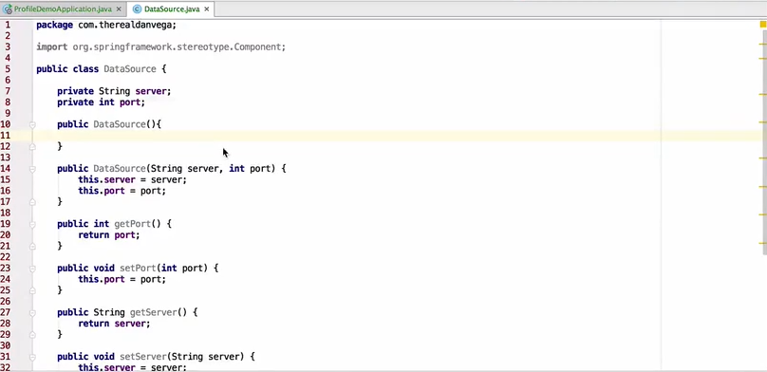

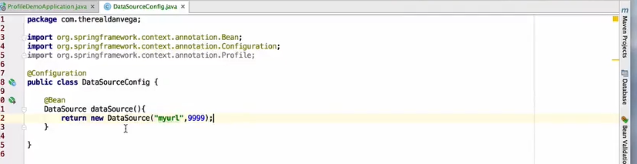

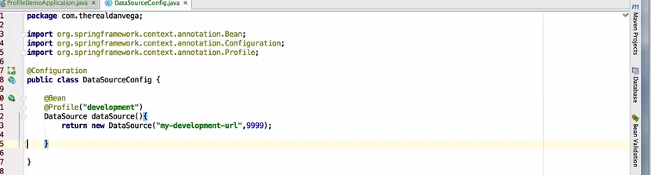

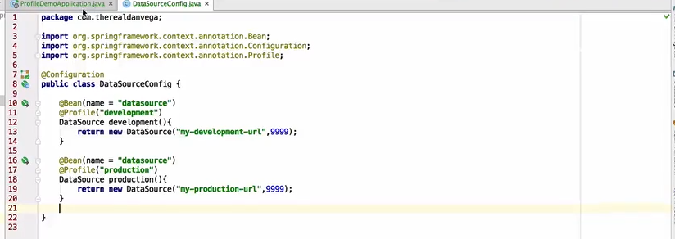

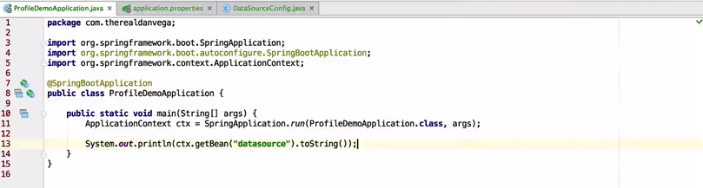

-based on active profile bean will be selected

-If we have bean with no profile it will always load bean with no profile only

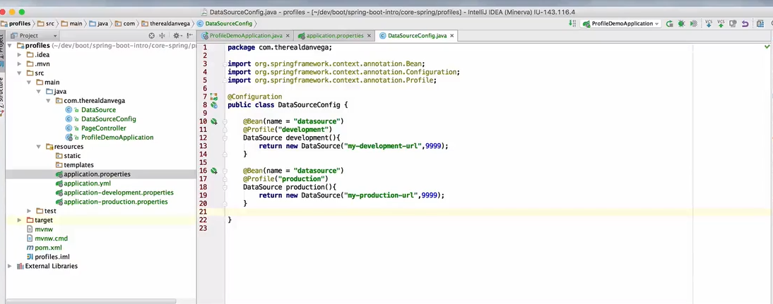

Auto Configuration

- imp concept

- bcz lot of spring boo features exist bcz of these feature

- Spring Boot Auto configuration try to automatically confif our spring application based jar dependency

Ex:

1 if HSQL db in class path and mannuly configured any db connection spring will automatically configure in memory db

2 Spring MVC in class path want dispatecher servlet setup at any point if we start define our own configuration to replace specific part of auto config is possible

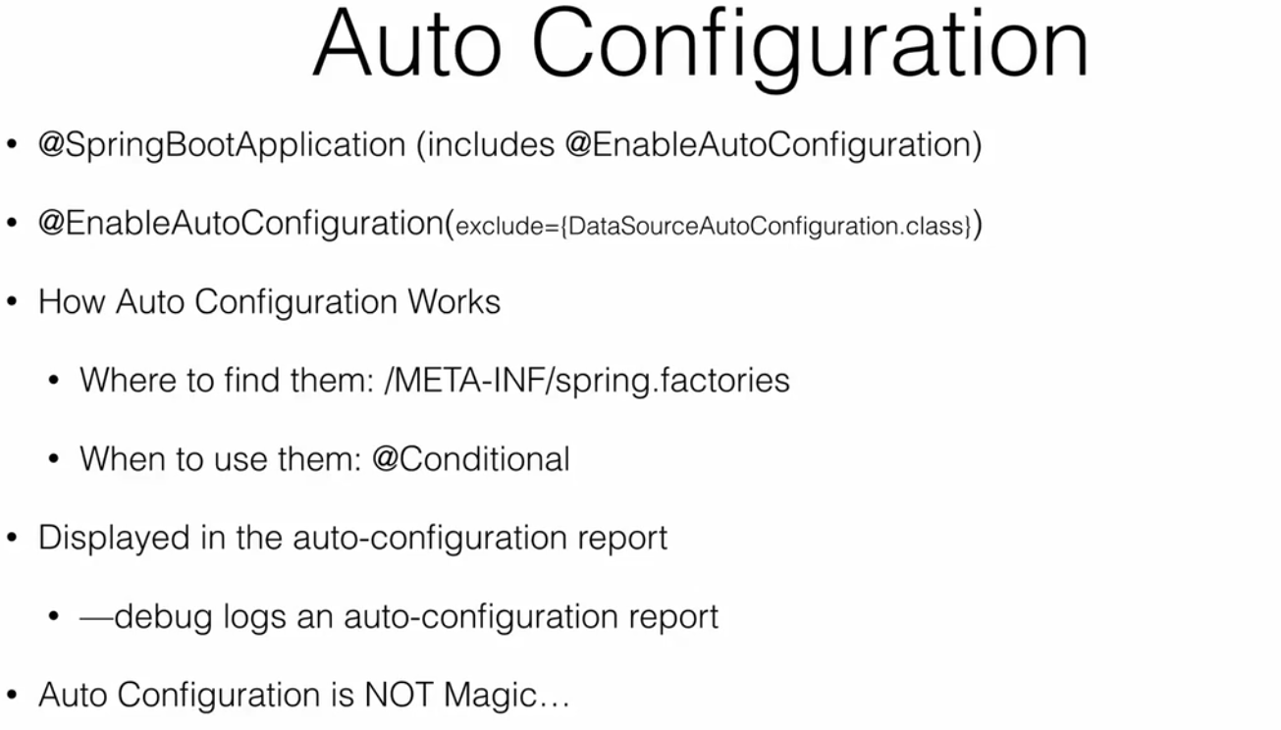

-to get autoconfig report

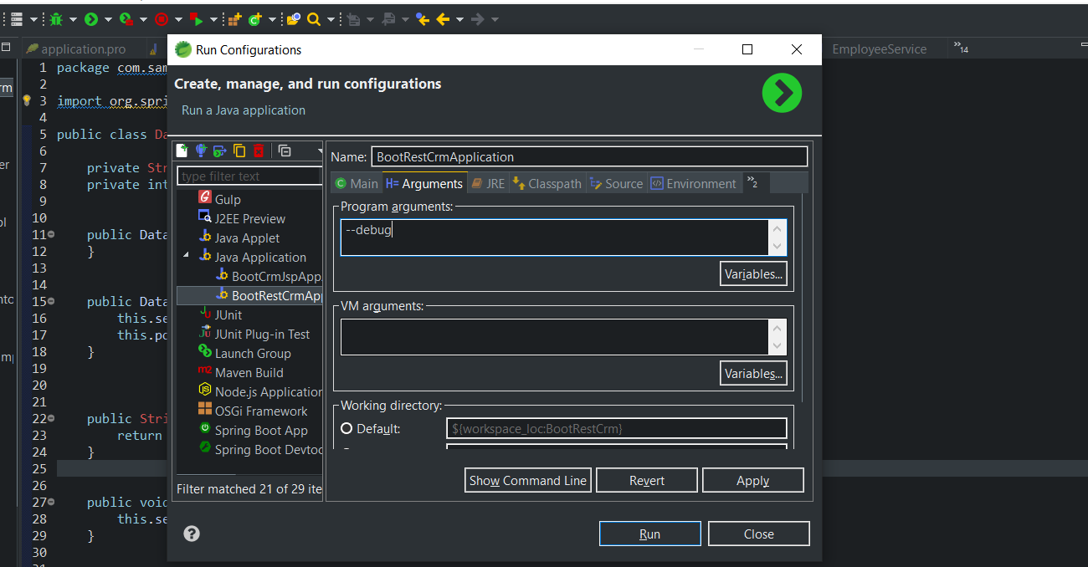

- auto config report and y

- we can see positive and negative match

-positive which are actual required

- negative match they are around n no reason fr them to around

- exculsion cases

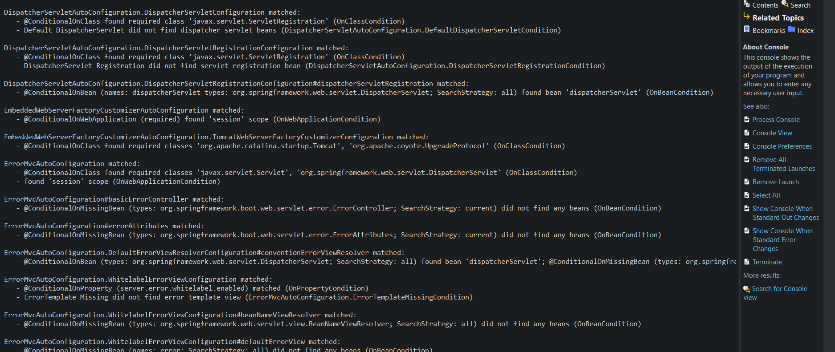

- to check auto fig class and its dependency go to spring-boot-stater-autoconfig jars path chck any like thymleaf

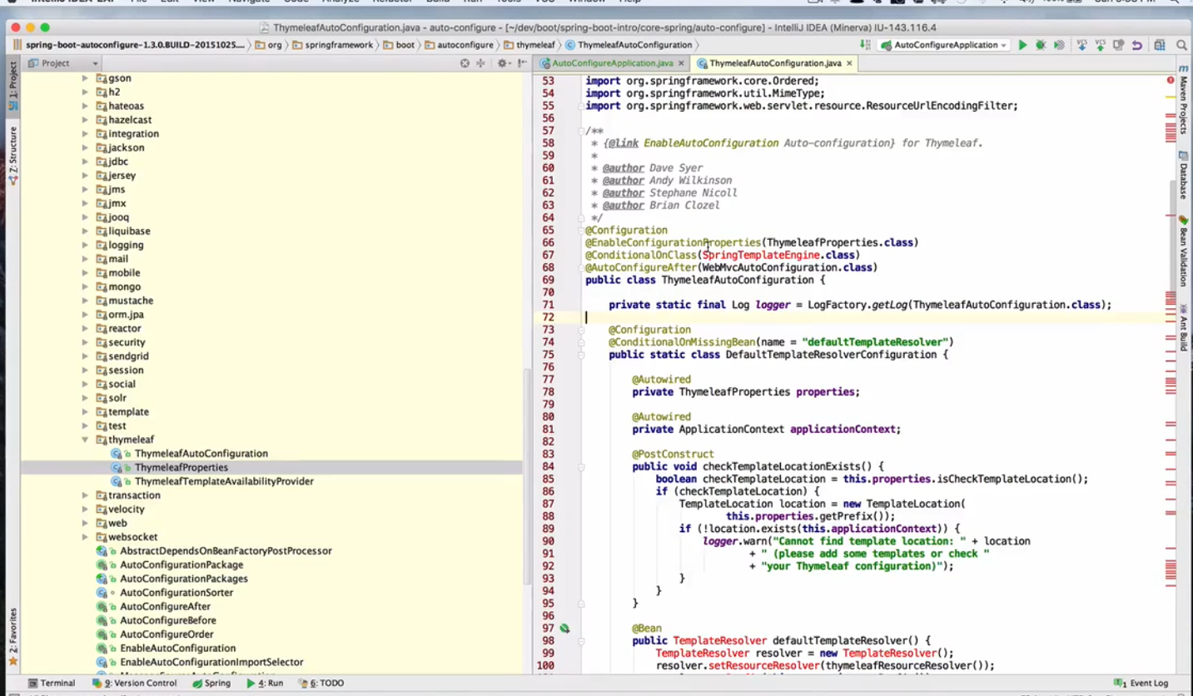

-check putting condition on auto config class and types of conditions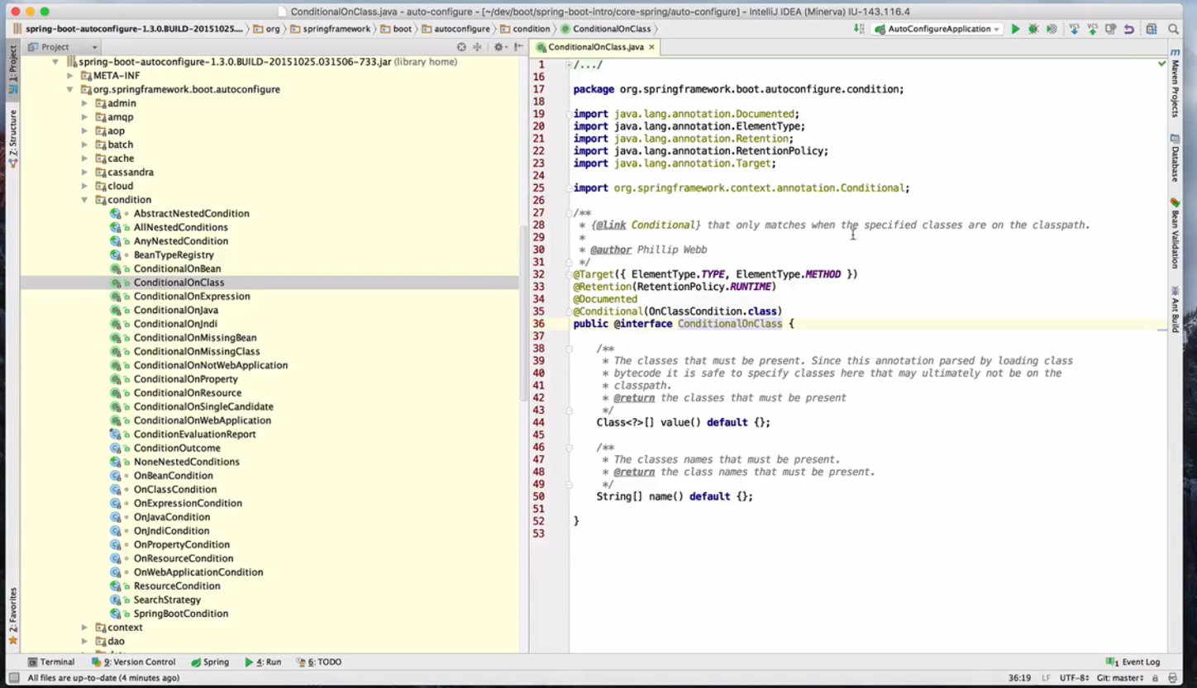

Web Development

Spring MVC

-leading web framework

-Model => application data

-View => view is interface to render model

-Controller => Traffic controller between model and view

Spring MVC is a controller action based framework request are mapped to controller methods and methods are responsible for returning what ever it supposed to be

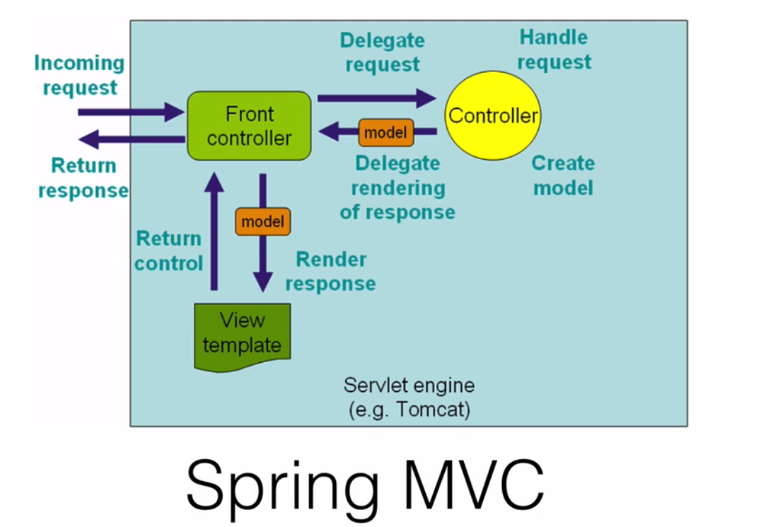

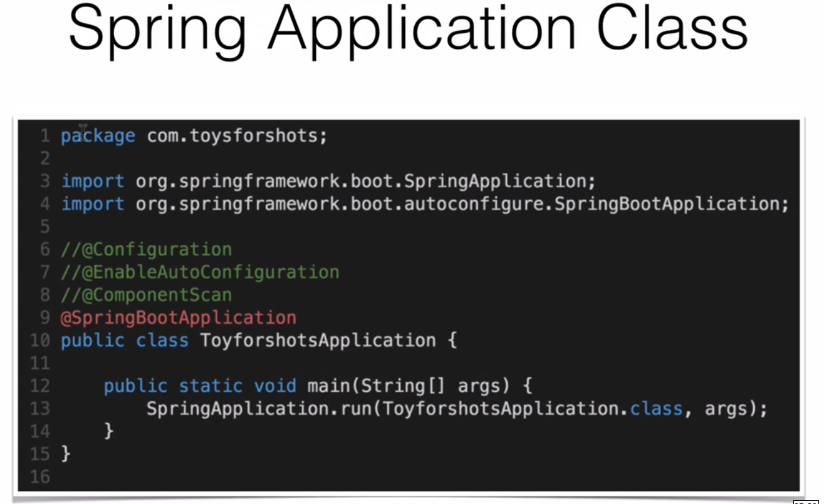

- Main file where all starts

@configuration,@EnableAutoConfiguration,@ComponentScan 3 are common annotation so boot decided to use @SpringBootApplication which internally calls these 3 anotations

@Configuration tags bean defination to application context

@EnableAutoConfiguration tells spring boot add beans based on class path

- in spring mvc application @EnableWebMVC is need to added in configure class to make this has SpringWebMVC configuration

-but in boot it will add automatically these once it find mvc in its class path and activate its key behaviour like adding dispatcher servlet etc

-ComponetScan to look for compent ,service in same package

-SpringApplication.run() to launch applciation

- no xml 100% java configuration

Creating A Web App toyjoyshop

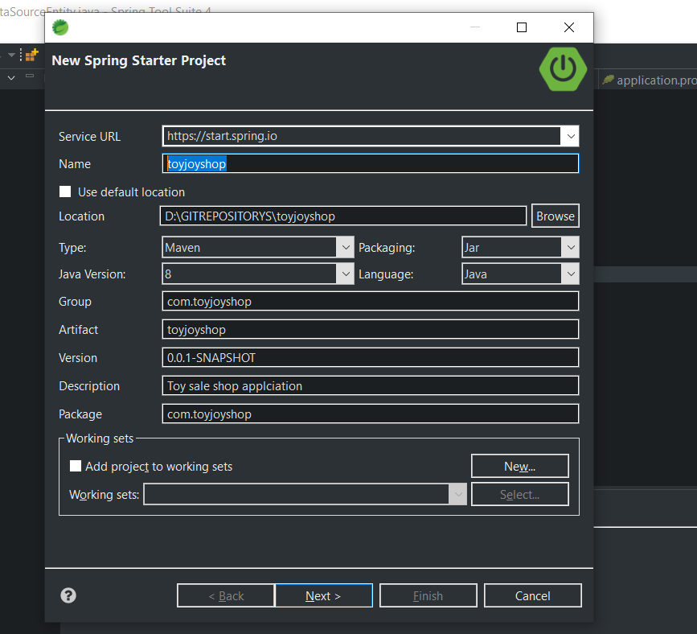

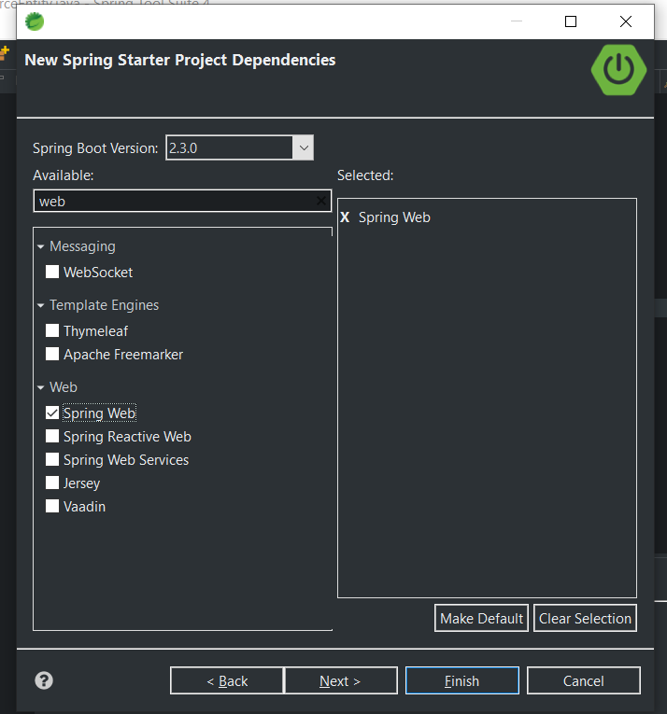

- Workspace built

-check pom file

-Run it uses localhost:8080 to home path if 404 then add index.html to map it in static folder

- any static data use these folder and access directly example html,jss,css,image etc

- template folder will be used when we go for template engines

- directly use static html and jpg directly from static folder all will handled by

- static directory can have sub directory for css,js etc

Static Content

-CSS , JS,Images,HTML ,WEBJAR

-by default spring boot willl server static content from static directory from the class path r root path of context

- override can be done fr that locations

- dnt use source/main/webapp directory if package is gng to be as a jar

-all the above directory is common standard only work with war package and silently ignored by most build tools if u generate jar

- in additon to standard static resource location above a spl case made a WEBJAR content

- any resource with a path webjar in it will serverd from jar pacakage in it web jar format

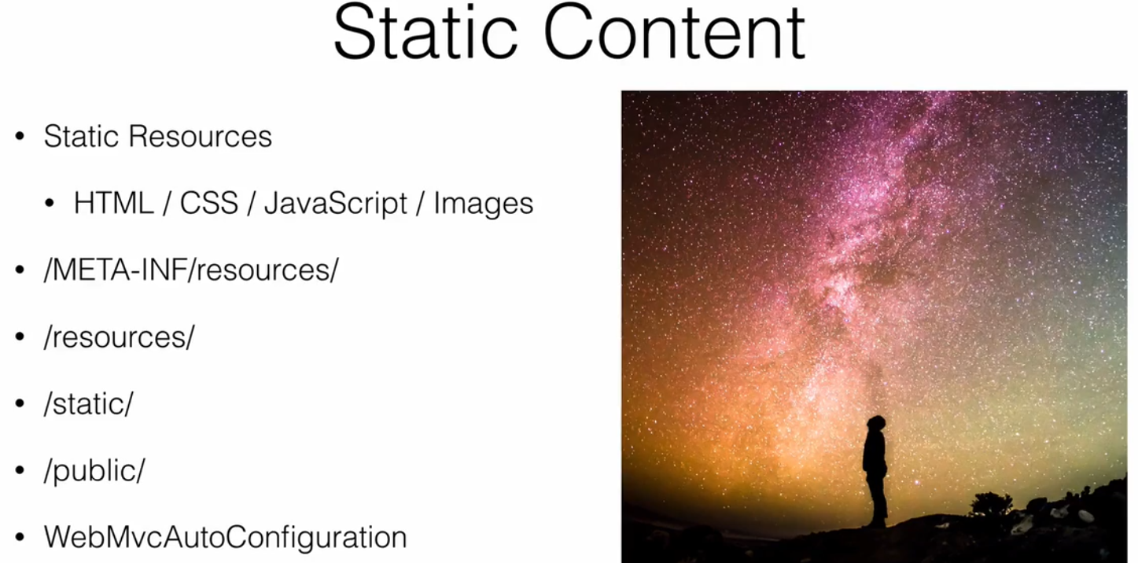

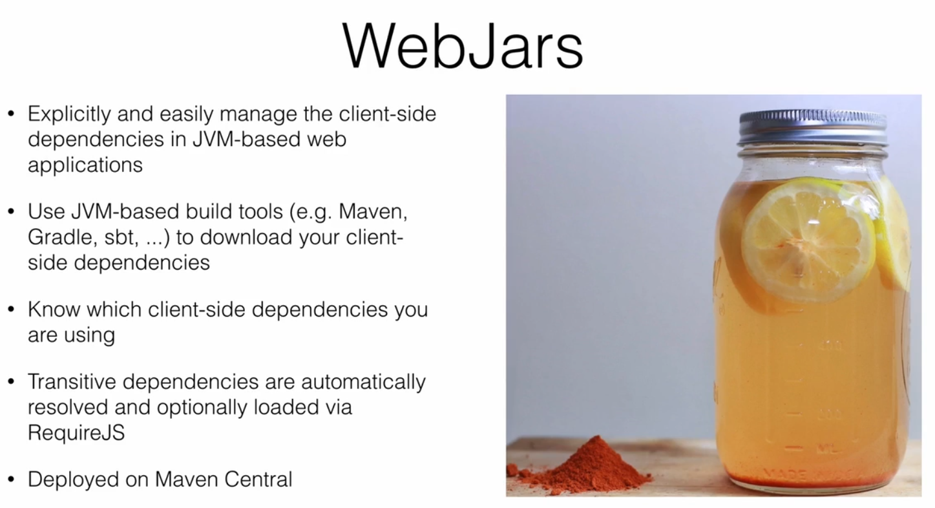

Using Web jars

<https://www.webjars.org/>

-Bootstrap and jquery version select version and maven path place in pom.xml

-It will download n load but to find path will not we visible just webjars path followed by folder structure

-it will work same as static folder static files better use webjars dependency

Similar to WEBJARS we can use BOWER

Bower

- Bower => A Package manager for the web

-same like webjars

- include all client side tools

- its tool combined with grunt

- client side developer using this side

- <https://gruntjs.com/> => grunt java script task runner have plugins to also helps in automation

-search packages

For NPM command install nodejs package

To run commands of npm

<https://nodejs.org/en/>

-once installed and path is been set

Download Git

<https://gitforwindows.org/>

Set git\bin and git\cmd path to enviornament variable and run depends to bower installation

Required compulsory

npm install -g bower

Install packages with [bower install](https://bower.io/docs/api" \l "install). Bower installs packages to bower_components/.

bower install <package>

# installs the project dependencies listed in bower.json

bower install# registered package

bower install jquery# GitHub shorthand

bower install desandro/masonry# Git endpoint

bower install git://github.com/user/package.git# URL

bower install http://example.com/script.js

### Search packages

[Search Bower packages](https://bower.io/search) and find the registered package names for your favorite projects.

### Save packages

Create a bower.json file for your package with [bower init](https://bower.io/docs/creating-packages/" \l "bowerjson).

Then save new dependencies to your bower.json with bower install PACKAGE --save

### Use packages

How you use packages is up to you. We recommend you use Bower together with [Grunt, RequireJS, Yeoman, and lots of other tools](https://bower.io/docs/tools/) or build your own workflow with [the API](https://bower.io/docs/api/). You can also use the installed packages directly, like this, in the case of jquery:

<script src="bower_components/jquery/dist/jquery.min.js"></script>

- with worksapce

-cmd goto project path

- create file .bowerrc and add directory path

{

"directory":***"src/main/resources/static/lib/"***

}

-then run below commands and follow step it will create a json file for us

- later check if npm and git installed imp then

- bower install

-bower install jquery

- if already jquery path is there do force install

-bower install --force

- bower install bootstrap

-bower install bootstrap --force

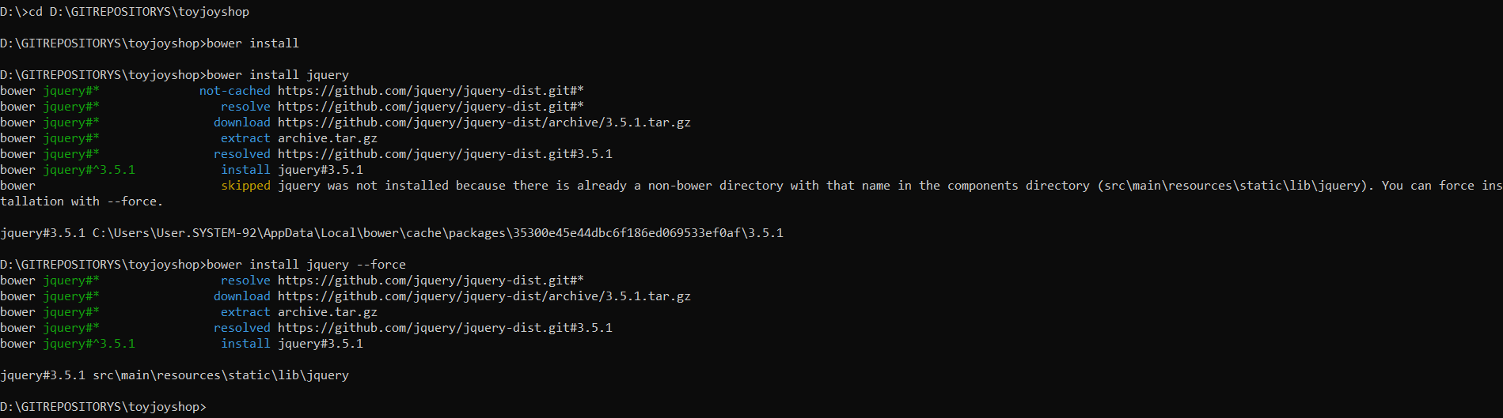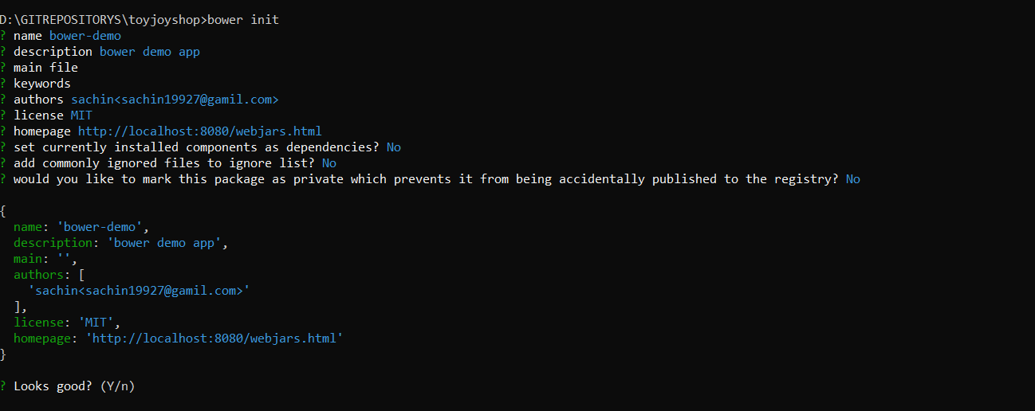

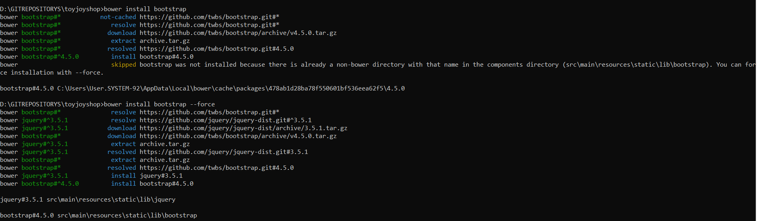



-when using this template this wil be automatically taken form src/main/resource/template diectory

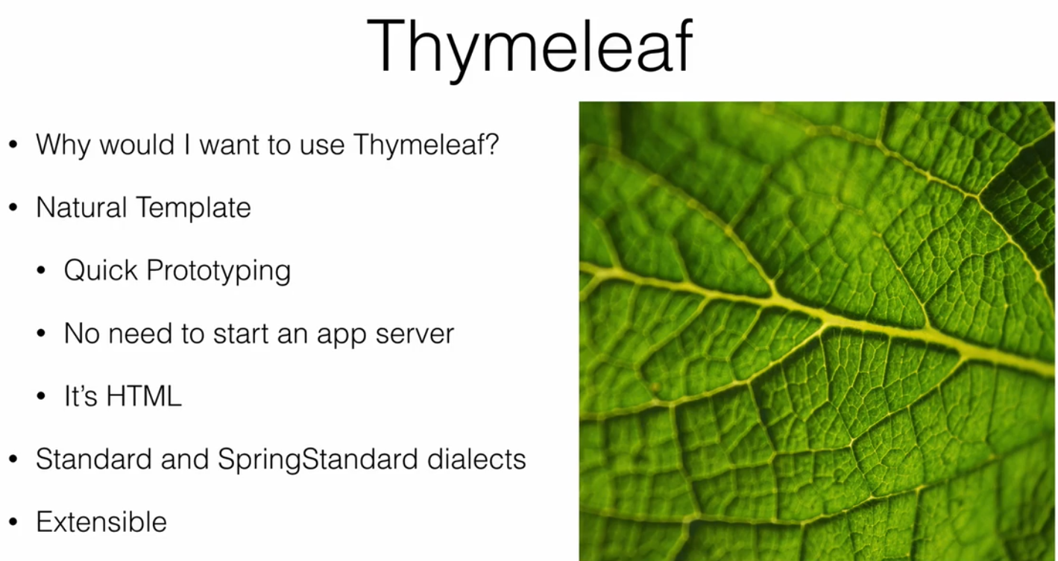

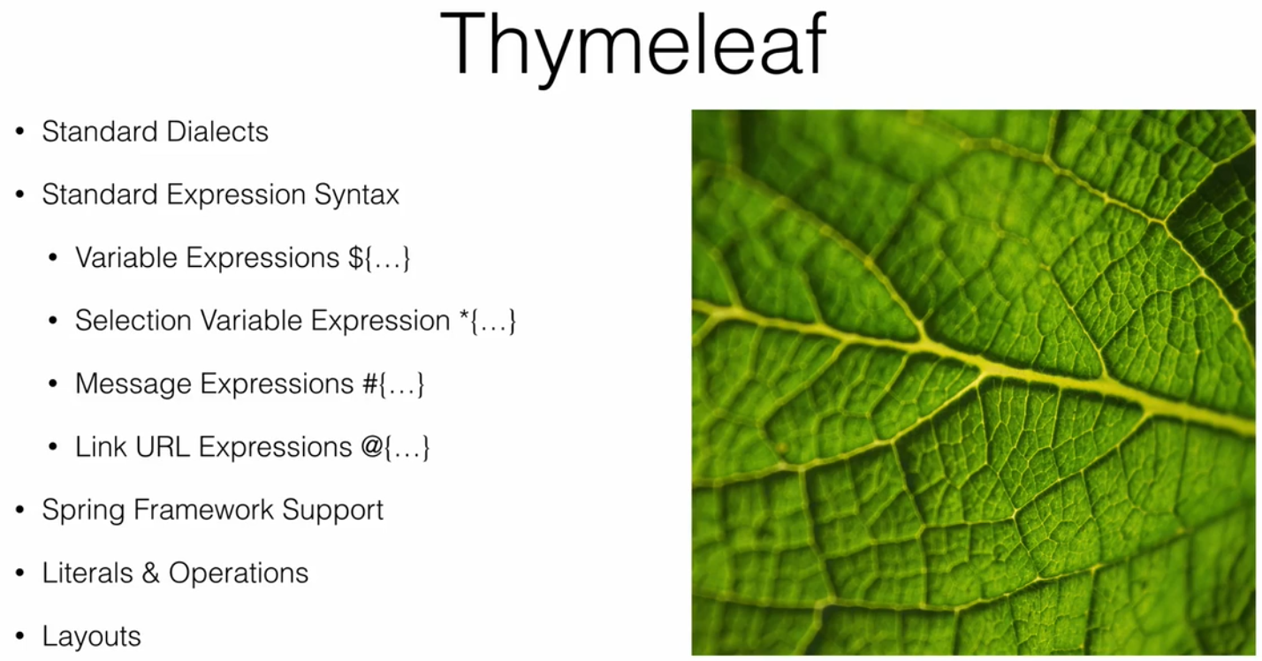

-this template will be documnet as final result I.e HTMl where syntax doesn’t break document strcture like JSP

- easy to identify bcz it starts with th prefix

- expression lang supportd

-spring framowrk features, literal operation supported

-dynamic template can be created using layout

For info : <https://www.thymeleaf.org/>

-most of the templating engines have cache property in developement we dnt want restart my server every time production it shoud not be on

- turn of the cache in application.propertice

-even if we use devtools which will turn off cache of all template engines

- include th namesapce which will be pointing to xmlns:th="http://www.thymleaf.org"

-Override the original Document with the custom document

- basically override will take data form model r dynamic data if there is not dynamic data it will show original document value which will ensure HTML will be visible

- original HTML will maintained same like that with out any interuption

Ex:

<!-- page title th:text=${pageTitle} (variable Expression) will take this value and set it to title if there is no key like that it will show orignal document -->

<title th:text="${pageTitle}">Blog Post-List</title>

<!-- CSS -->

<link href="/lib/bootstrap/dist/css/bootstrap.min.css" rel="stylesheet" th:href="@{/lib/bootstrap/dist/css/bootstrap.min.css}" />

<!-- @{} url exppression based on where we are in application -->

<link href="../static/css/blog.css" rel="stylesheet" th:href="@{/css/blog.css}" />

<script src="/lib/jquery/dist/jquery.min.js" type="application/javascript" th:href="@{/lib/jquery/dist/jquery.min.js}" ></script>

For html designer it will show his document for us it shows developer changes

<!-- Display Each Post th:each="post: ${posts}" -->

<article th:each="post: ${posts}">

<header>

<h1 th:text="${post.title}">My Blog Post Title</h1>

<p th:text="${post.posted}">Posted on Oct 31,2020 at 10.00 AM</p>

<p th:text="${#calendars.format(post.posted,'dd/mm/yyyy')}">Posted on Oct 31,2020 at 10.00 AM</p>

<!-- Use thymleaf Expression utility object -->

</header>

<!-- if any html comping from controller will be escaped if we use th:text so use th:utext to use it has a raw content-->

<section th:utext="${post.body}">

<p>Lorem Ipsum is simply dummy text of the printing and typesetting industry. Lorem Ipsum has been

the industry's standard dummy text ever since the 1500s, when an unknown printer took a galley of type

and scrambled it to make a type specimen book. It has survived not only five centuries, but also

the leap into electronic typesetting, remaining essentially unchanged. It was popularised in the

1960s with the release of Letraset sheets containing Lorem Ipsum passages, and more recently with

desktop publishing software like Aldus PageMaker including versions of Lorem Ipsum.</p>

</section>

<footer>

<address>

Posted by: <span th:text="${post.author}">Guest User</span>

</address>

</footer>

<hr/>

</article>

Ex Post Blog

1 Post Entity

2 Post Controller

GSP Template

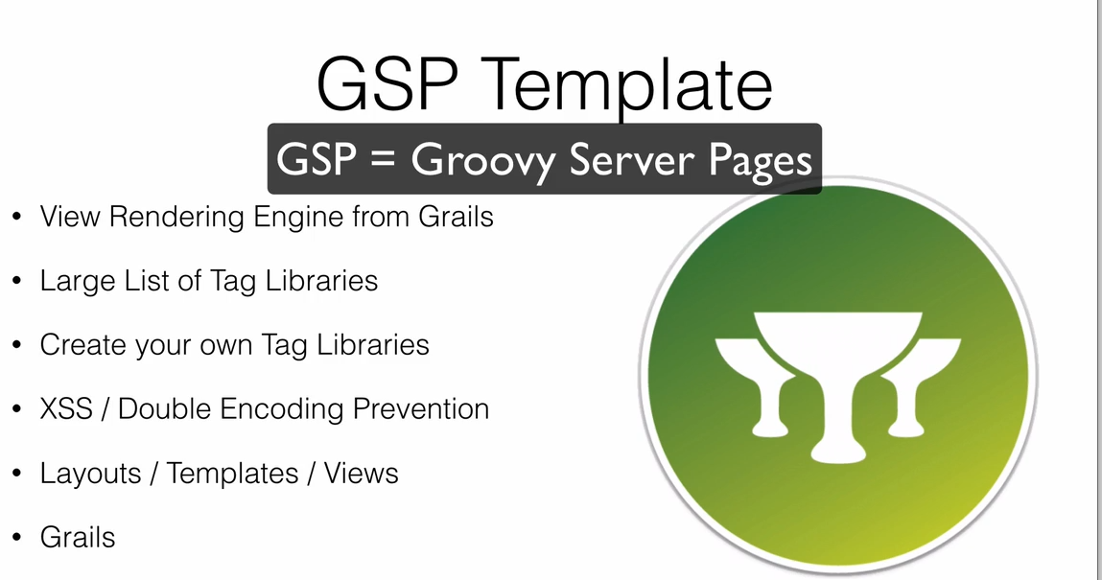

-similar to JSP

- allows static and dynamic content in document

- advantage lot of tag libraries

- we can use already created tag library r can create new library easy one

- Grails framework

-cache disable not required bcz every time we make change it recompile

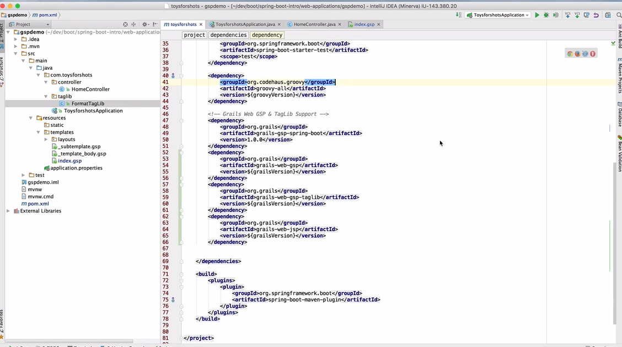

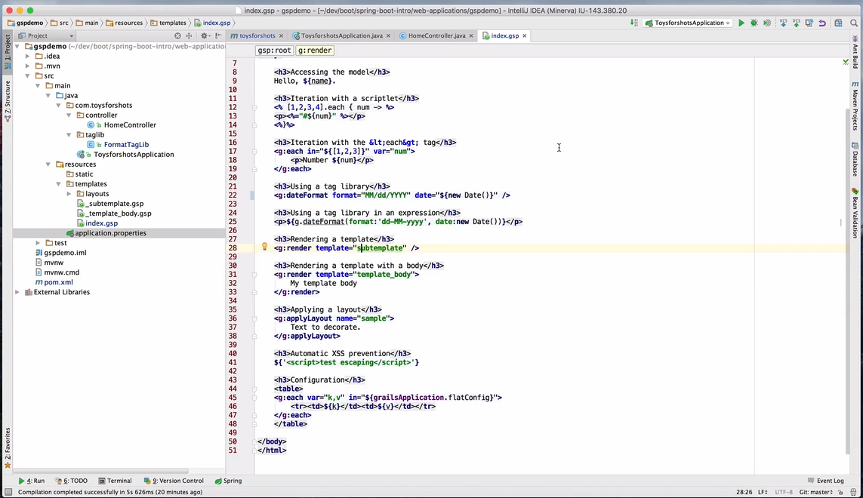

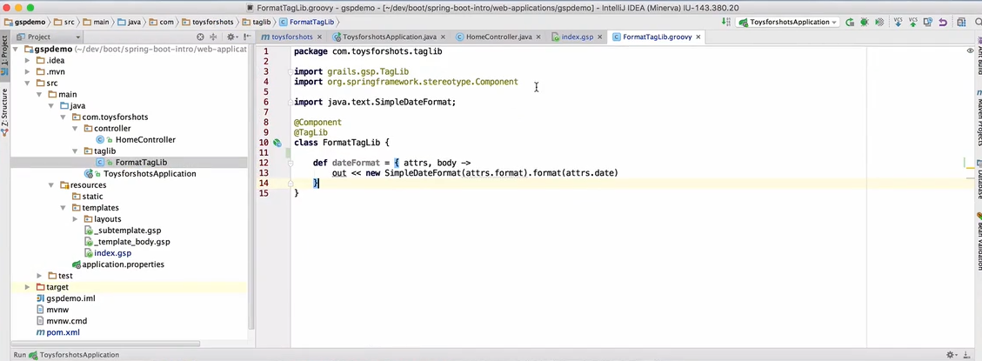

- to add templates crate file with _template name while rendring give template name no need of _ it will understand

Internationlization i18n

- planning and adopting languages to adopt local languages

- making applcaiton available to other locals

- autoconfiguration already handled i18n so no need to configure it

-messages.properties will be default if nothing found this will be used as default

spring.mvc.locale=ka

spring.mvc.locale-resolver=fixed

Error Handling

- spring boot provide error mapping by default

-handles all our error in a sensible way and registerd as global error page in servlet Container

-for REST client it produce JSON with details of error ,http status and error msg

- for bowser client there is a white lable error view

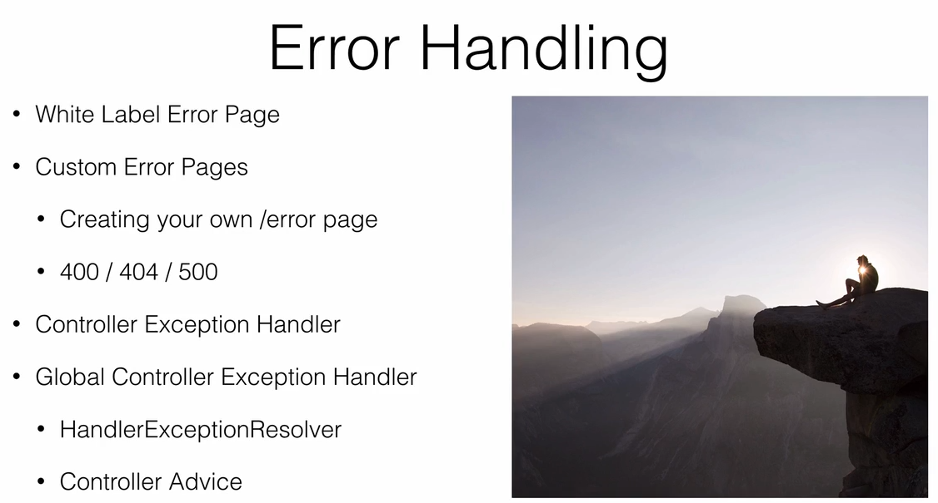

- add error.html in template and add error and msg values dynamically boot will handle it

- this will overide default global error handler

- there may to add extra funtionality addition data to the view more contoll over error

-create a controller with implements ErrorController and configure it

@Controller

public class CustomErrorController implements ErrorController {

private static final String ERROR_PATH="/error";

private static final String ERROR_TEMPLATE="customError";

private final ErrorAttributes errorAttributes;

public CustomErrorController(ErrorAttributes errorAttributes) {

this.errorAttributes = errorAttributes;

}

@GetMapping(ERROR_PATH)

public String error(Model model,HttpServletRequest request)

{

Map<String, Object> error=getErrorAttributes(request,true);

model.addAttribute("timestamp", error.get("timestamp"));

model.addAttribute("status", error.get("status"));

model.addAttribute("error", error.get("error"));

model.addAttribute("message", error.get("message"));

model.addAttribute("path", error.get("path"));

// loggs can be added here

return ERROR_TEMPLATE;

}

public String getErrorPath() {

return ERROR_PATH;

}

private Map<String, Object> getErrorAttributes(HttpServletRequest request, boolean includeStackTrace) {

//RequestAttributes requestAttributes=new ServletRequestAttributes(request);

ServletWebRequest servletWebRequest = new ServletWebRequest(request);

return this.errorAttributes.~~getErrorAttributes~~(servletWebRequest, includeStackTrace);

}

- Error Template to handle very specific template code

// to handle a particular req

@GetMapping("/404")

public String pageNotFound(Model model,HttpServletRequest request)

{

model.addAttribute("error", getErrorAttributes(request, true));

return "404";

}

@GetMapping("/500")

public String errorInPage(Model model,HttpServletRequest request)

{

model.addAttribute("error", getErrorAttributes(request, true));

return "500";

}

@GetMapping("/401")

public String unAuthorized(Model model,HttpServletRequest request)

{

model.addAttribute("error", getErrorAttributes(request, true));

return "401";

} }

Adding this and html page wont fix need to work on SpringBoot main class also

@Bean

public WebServerFactoryCustomizer<ConfigurableServletWebServerFactory> containerCustomizer() {

return (container -> {

ErrorPage error401Page = new ErrorPage(HttpStatus.UNAUTHORIZED, "/401");

ErrorPage error404Page = new ErrorPage(HttpStatus.NOT_FOUND, "/404");

ErrorPage error500Page = new ErrorPage(HttpStatus.INTERNAL_SERVER_ERROR, "/500");

container.addErrorPages(error401Page, error404Page, error500Page);

});

}

Exception Handling

-handling exception at controller level

- handling All exception and with one method are seprate method fr differnt Exception

- instead of writing like this in every controller can make a Gloabal one

@GetMapping("/get/{slug}")

public String bolgList(@PathVariable("slug") String slug) throws Exception

{

BlogPost post=null;

if(post==null) throw new Exception("No record found for slug "+slug);

return "post";

}

//this is to handle all expection if particualr Excecption need to handle that Excpetion calss and view is reuireed

// instead of that writng this all controller we can make it golbal controller

@ExceptionHandler(Exception.class)

public String exceptionHandler(HttpServletRequest request,Exception exception,Model model)

{

model.addAttribute("errorMessage", exception.getMessage());

return "postError";

}

-

Spring Data Data Access

1 H2 database

- add dependency

To access it console h2 database

spring.h2.console.enabled=true

spring.h2.console.path=/console

<http://localhost:8080/console>

- no need to instal h2 database all will be taken care by dependency

If connection not establishing

Add these in application.properties

spring.datasource.url=jdbc:h2:mem:devDb

spring.datasource.driverClassName=org.h2.Driver

spring.datasource.username=sa

spring.datasource.password=

spring.jpa.database-platform=org.hibernate.dialect.H2Dialect

Creating Entity Repositrys

1 BolgPost, Author and ManytoOne Relation

2 once application statrted automatically it creates table and once down automatically it will clreaed since it is inmemeory db

insert into AUTHOR values(1,'Sachin','Gowda');

insert into BLOG_POST(ID ,TITLE ,BODY ,POSTED ,AUTHOR_ID ) values(1,'My First Blog','Blog Body',CURRENT_DATE(),1);

- to get data In load we have to options

1 can load data using SQL file

2 are by programitcally

will use JPA REpostiory to do all works by extending CurdRepository /JPARepository=> check its internal implementations

1 By SQL file

In application.properties

2 Progrmatically

Create DataLoader Service

To load the DB data

@Service

public class DataLoader {

private static final Logger logger=LoggerFactory.getLogger(DataLoader.class);

private BlogPostRepository postRepository;

private AuthorRepository authorRepository;

@Autowired

public DataLoader(BlogPostRepository postRepository,AuthorRepository authorRepository) {

this.postRepository=postRepository;

this.authorRepository=authorRepository;

}

@PostConstruct

private void loadData()

{

// create new author

Author auth=new Author("Sachin","Gowda");

authorRepository.save(auth);

//create BlogPost

BlogPost post= new BlogPost();

post.setTitle("My Data Blog");

post.setBody("<p>Full details of my blog</");

post.setPosted(new Date());

post.setAuthor(auth);

postRepository.save(post);

}

}

MAin Calss

// BlogPost Repository

@Autowired

BlogPostRepository postRepository;

@Autowired

DataLoader dataLoad;

public static void main(String[] args) {

SpringApplication.run(ToyjoyshopApplication.class, args);

}

// Post Construct run this method after everything is been set up

@PostConstruct

void seePosts()

{

logger.info("post Method data");

for(BlogPost post: postRepository.findAll()) {

logger.info(post.toString());

}

}

Refactor Code

Custom Query to JPARepo

Refer : <https://docs.spring.io/spring-data/data-commons/docs/1.6.1.RELEASE/reference/html/repositories.html>

Can limit the size of query

Like TOP,FIRST

thymleaf layout dependency to make it a layout one

Now moving from Inmemory h2 data base to production db;

H2 being used for test envioronment and Posgress for production use profiles

Run Query in postgress

insert into AUTHOR(ID,FIRST_NAME,LAST_NAME,EMAIL) values(1,'Sachin','Gowda','sachin19927@gamil.com');

insert into AUTHOR(ID,FIRST_NAME,LAST_NAME,EMAIL) values(2,'Sachin','Gowda','sachin19927@gamil.com');

insert into BLOG_POST(ID ,TITLE,SLUG,TEASER,BODY ,POSTED ,AUTHOR_ID ) values(1,'My Blog post 1','post_slug1','<p>test teaser</p>','<p>Full body </p>',CURRENT_DATE,1);

insert into BLOG_POST(ID ,TITLE,SLUG,TEASER,BODY ,POSTED ,AUTHOR_ID ) values(2,'My Blog post 2','post_slug2','<p>test teaser</p>','<p>Full body </p>',CURRENT_DATE,1);

insert into BLOG_POST(ID ,TITLE,SLUG,TEASER,BODY ,POSTED ,AUTHOR_ID ) values(3,'My Blog post 3','post_slug3','<p>test teaser</p>','<p>Full body </p>',CURRENT_DATE,1);

insert into BLOG_POST(ID ,TITLE,SLUG,TEASER,BODY ,POSTED ,AUTHOR_ID ) values(4,'My Blog post 4','post_slug4','<p>test teaser</p>','<p>Full body </p>',CURRENT_DATE,2);

insert into BLOG_POST(ID ,TITLE,SLUG,TEASER,BODY ,POSTED ,AUTHOR_ID ) values(5,'My Blog post 5','post_slug5','<p>test teaser</p>','<p>Full body </p>',CURRENT_DATE,2);

insert into BLOG_POST(ID ,TITLE,SLUG,TEASER,BODY ,POSTED ,AUTHOR_ID ) values(6,'My Blog post 6','post_slug6','<p>test teaser</p>','<p>Full body </p>',CURRENT_DATE(),2);

JPA is good but it will be heavy In certain situations

To use light weight if we dnt map object to entity then JDBC TEMPLATE for us

JDBC Template

- replace spring-boot-starter-jpa to spring-boot-starter-jdbc

- since we are not allowing hibernate to create table for us we need to create scehma and table for us

- we need to create the schema here since it not created

Filw :schema-h2.sql

Add creation query;

DROP TABLE IF EXISTS AUTHOR;

CREATE TABLE AUTHOR(

id bigint NOT NULL,

first_name varchar(100),

last_name varchar(100),

email varchar(100),

PRIMARY KEY (id)

);

DROP TABLE IF EXISTS BLOG_POST;

CREATE TABLE BLOG_POST(

id bigint NOT NULL,

title varchar(100),

slug varchar(100),

teaser varchar(4000),

body varchar(4000),

posted TIMESTAMP,

author_id bigint,

PRIMARY KEY (id)

);

-Followed by insert query in data-h2.sql

- since its JDBC no need to @Entity annotaation it will be same plain POJO but no JPA mapping

- Will have own DataImpl class where JDBC template will be called and mapped with POJO class

-tat it will work fine like JPA stage in JDBC template also

NoSQL -MangoDB

Spring Boot

- take same provious app only

Remove h2 reference in appilcation properties

And add mongoDb referenc in applciation properties

- remove jpa / jdbc from pom and replace spting=boot-starter-data-mongodb

<dependencies>

<dependency>

<groupId>org.springframework.boot</groupId>

<artifactId>spring-boot-starter-data-mongodb</artifactId>

</dependency>

- remove @entity and @documnet annotaions for mongodb

Since evrything in Mongodb is collection

- mongodb don’t support bidirectional mapping like many to one

- @DBRef - tells that this collection is not embedded to this collection

- Repository wont change same interfac extending CurdRepository/MongoRepository

- mongo db holds cache not like it will kill once closed like h2 in case using DataLoader Delet it before adding

- in applciation.propeties

#config mongodb schema(DB) if this is not set it will take some test DB

spring.data.mongodb.database=customer

Customer : is the scehma here

#spring.data.mongodb.host=localhost

#spring.data.mongodb.port=27017

Mongodb port

#spring.data.mongodb.uri=mongodb://localhost:27017/customer

Above line can give same 3 property key functionality

#spring.data.mongo.repositories.enabled=true

- add thymeleaf depedency no extra is needed

- keep running mongodb

- install mongodb along with mongcompass rest it will work

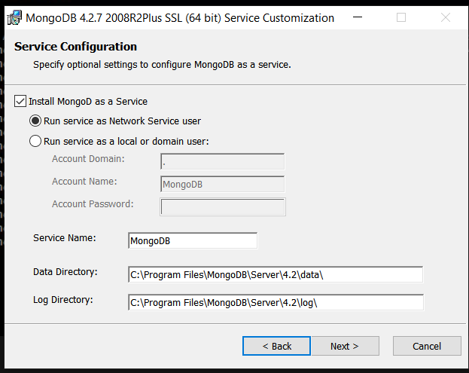

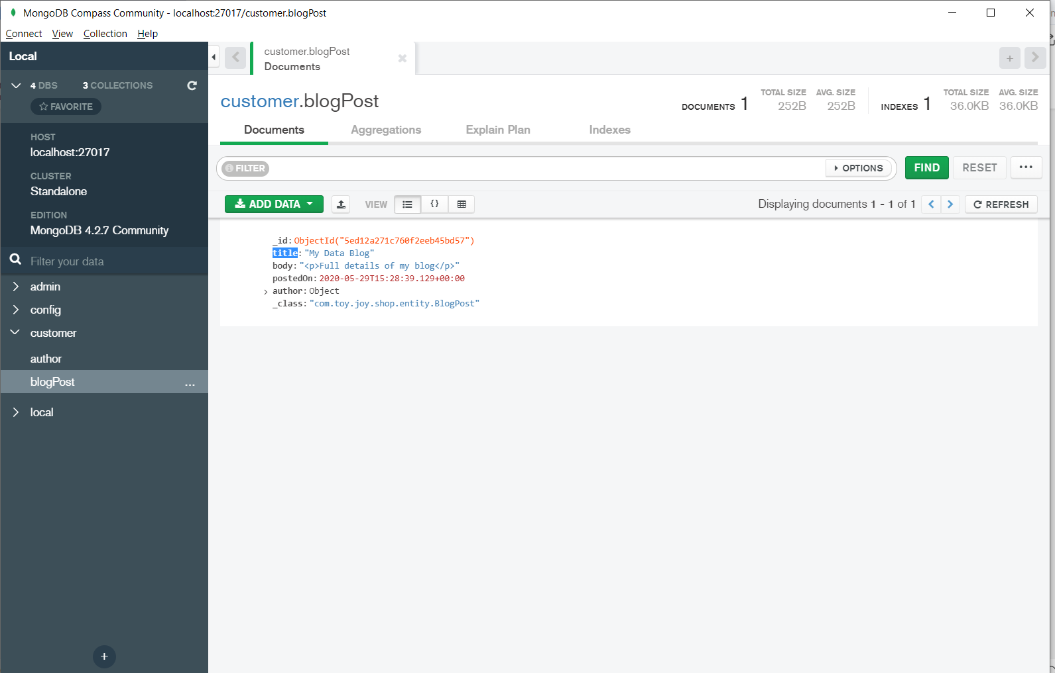

Creating Queries with JPA

- creating queries with Spring DATA JPA

-with implementing CrudRepository give basic save,find,delete query if extra custom Query required then

@ElementCollection to add list data it will be created as a Table only

Refer This: <https://docs.spring.io/spring-data/jpa/docs/1.10.x/reference/pdf/spring-data-jpa-reference.pdf>

Ex: To write a method to find Record start with “findAll” if u have condtionbased on Column then add “By” “findAllBy” ctrl+spcae it will give

- go to : Query Creation for details of creating one

- DynamicJPA methods fr getting data

- @Query HQL,NAMED,NATIVE query all completed

Spring Security (Spring Boot Security)

- Basic

- Custom Security

-Spring Secuirty With Data JPA

- Highly Secure Authentication and Accessing Framework

- The Factor Framework

- when spring-boot-starter-security depedency added what bascially we get

1 All HTTP end points are authenticated

2 default username is “user” and Password is random generated in console once app starts this all can be changed in application.properties file

3 security check ignored for static resources like css,js,iimages

4 Security Events that publish Succesfull and unsuccessfull Authorization and authentication Request

5 Security Headers Activated => HSTF,XSS,CSRF,Cache Controll

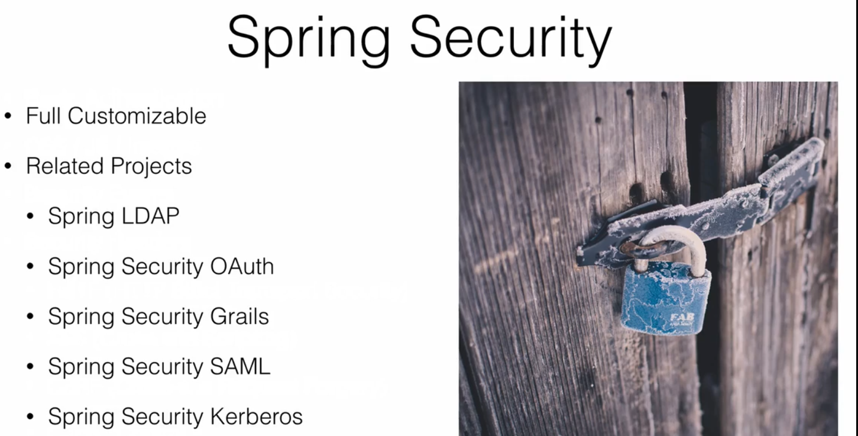

Spring Security is not only about Authentication and Accessing it is having much more then this

- change in application propertties

spring.security.user.name=sachin

spring.security.user.password=password

Custom Spring Security 1

- Configuring and Customizing out of the box of security

- Create a Scurity Configuration that gives the ability to start customize to our needs

- REF Document : <https://docs.spring.io/spring-security/site/docs/current/reference/pdf/spring-security-reference.pdf>

-For EnablingGlobalSpringSecuity

/**

*

* **@author** User

*

* **@Configuration** : > Indicates this class can be used has source of Bean Defination

* **@EnableGlobalMethodSecurity**(securedEnabled = true) : switches on spring seccurity method level feature using native annotaions

* this only works with class marked with **@configuration**

* Now we can Provide **@Security** Annotaion to method level request using this we can enable certain method with security

*/

@Configuration

@EnableGlobalMethodSecurity(securedEnabled = true)

public class SecurityConfig extends WebSecurityConfigurerAdapter{

}

@RestController

@RequestMapping("/secure")

public class DemoSecuirtyRestController {

@Secured("ROLE_GUEST") // restricting this method to only used by USER role

@GetMapping("/list")

public String list() {

return "List Posts";

}

@Secured("ROLE_USER") // restricting this method to only used by USER role

@GetMapping("/drafts")

public String viewDrafte() {

return "View Posts";

}

@Secured("ROLE_ADMIN") // restricting this method to only used by USER role

@GetMapping("/add")

public String add() {

return "add Posts";

}

}

spring.security.user.name=sachin

spring.security.user.password=password

#spring.security.user.role=USER

spring.security.user.role=USER,GUEST

#multiple Roles can be addded

Custom Spring Security 2

- remove/disable built in spring security from appication.properties file

- make production one configure

- @Secure annotations to secure method level access

// restricting this method to only used by USER role

@Secured("ROLE_USER")

@GetMapping("/drafts")

public String viewDrafte() {

return "View Posts";

}

- this require only USER role authentication to access this model for other case it wont allow

// restricting this method to only used by USER and ADMIN role

@Secured({"ROLE_ADMIN","ROLE_USER"})

@GetMapping("/update")

public String update() {

return "update post";

}

- for multiple role to access same method like this can be modified

- its only method access based in case if want to do ROLE based URL access rather then changing method.

- overide this method for LOGIN Credentials details protected void configure(AuthenticationManagerBuilder auth)

- overide this method ROLE BASE ACCESS AND LOGIN PAGE CUSTOM MODIFICATION protected void configure(HttpSecurity http)

@Autowired

protected void configure(AuthenticationManagerBuilder auth) throws Exception {

auth.inMemoryAuthentication()

.withUser("sachin").password("{noop}password").roles("ADMIN") // {noop} password encoder type * bcz it spring 5 project seprated encodeer congufure can be ex bcrypt

.and()

.withUser("darshan").password("{noop}password").roles("USER")

.and()

.withUser("manasa").password("{noop}password").roles("GUEST");

}

@Override

protected void configure(HttpSecurity http) throws Exception {

// security policy

http.authorizeRequests()

.antMatchers("/posts/list").permitAll() // permit for single url no login

.antMatchers("/posts/**").permitAll() // permit for this url pattern no login

.antMatchers("/secure/list").permitAll()

.antMatchers("/admin/**").hasRole("ADMIN") // permitting only for admin url pattern

.anyRequest().authenticated() // to login

.and()

.formLogin() // login can custom login page

.and()

.logout(); // logout can custom this also

}

Creating Custom Login Form

- custom login form

- spring security tags w.rt to Thymeleaf

- add these depedency for thymeleaf and spring secutity depedency dialest features

<!-- https://mvnrepository.com/artifact/org.thymeleaf.extras/thymeleaf-extras-springsecurity5 -->

<dependency>

<groupId>org.thymeleaf.extras</groupId>

<artifactId>thymeleaf-extras-springsecurity5</artifactId>

</dependency>

- always want check matching and unmatching dependency just add

debug=true in application.properties

Csrf value changes on each session and value that supply should match with value held in server’

-csrf is a autogenerated value

With taking this value cnt be hacked since value wil be changes in server side

Form page:

<form name="f" th:action=@{/login} method="POST" class="form-signin">

<h2 class="form-signin-heading" >Please Sign In</h2>

<div th:if="${param.error}" class="alert alert-danger">

Invalid UserName and Password

</div>

<div th:if="${param.logout}" class="alert alert-success">

You have been logged out

</div>

<label for="username" class="sr-only">Username</label>

<!-- <input type="text" id="username" name="username" class="form-control" placeholder="Username" required="true"/> -->

<input type="text" id="email" name="email" class="form-control" placeholder="Username" required="true"/>

<label for="password" class="sr-only">Password</label>

<input type="password" id="password" name="password" class="form-control" placeholder="Password" required="true"/>

<div class="checkbox">

<label>

<input id="remember-me" name="remember-me" type="checkbox"/> Remember me

</label>

</div>

<button class="btn btn-lg btn-primary btn-block" >Sign In</button>

</form>

Logout option

</form>

<div class="navbar-text navbar-right">

Welcome<span sec:authentication="name">Guest</span>

<form sec:authorize="isAuthenticated()" id="frmlogout" th:action="@{/logout}" method="POST" class="form-inline">

<a href="javascript:{}" onclick="document.getElementById('frmlogout').submit(); return false;">Logout</a>

</form>

Spring secuity with JPA

- Set SecurityConfig file to access from UserDetailService

@Configuration

@EnableGlobalMethodSecurity(prePostEnabled = true,securedEnabled = true)

//@Order(SecurityProperties.ACCESS_OVERRIDE_ORDER)

public class SecurityConfig extends WebSecurityConfigurerAdapter{

@Autowired

private UserDetailsService userService;

@Autowired

protected void configure(AuthenticationManagerBuilder auth) throws Exception {

// using UserDetailsService for login JPA data

auth.userDetailsService(userService);

}

@Override

protected void configure(HttpSecurity http) throws Exception {

// security policy

http.authorizeRequests()

.antMatchers("/registration**","/js/**","/css/**","/images/**","/webjars/**").permitAll()

.antMatchers("/posts/**").permitAll() // permit for this url pattern no login

.antMatchers("/secure/list").permitAll()

.antMatchers("/secure/admin/**").hasRole("ADMIN") // permitting only for admin url pattern

.anyRequest().authenticated() // to login

.and()

.formLogin() // login can custom login page

.loginPage("/login") // can be done mapping controller also but will try to this buy configure class

.usernameParameter("email") // by default it take form username parameter but if it need to consider different one please assign custome feild name

.permitAll() // if this is not addeded this will also show Accessdenied since Secuity enabled every where so permit all make it accessicale to login page

.and()

.logout() // logout can custom this also

.logoutSuccessUrl("/login?logout")

.permitAll();

}

}

Create Entity User, Roles

@Entity

@Table(name="users")

public class User {

@Id

@GeneratedValue

private Long id;

@Column(unique = true, nullable = false)

private String email;

@Column(nullable = false)

private String password;

private String userName;

private String fullName;

@ManyToMany(cascade = CascadeType.ALL,fetch = FetchType.EAGER)

@JoinTable(

name ="users_roles",

joinColumns = {@JoinColumn(name="user_id")}, // FK to USER

inverseJoinColumns = {@JoinColumn(name="role_id")} // FK back to Role object

)

private Set<Roles> roles =new HashSet<Roles>();

}

@Entity

@Table(name="roles")

public class Roles {

@Id

@GeneratedValue

private Long id;

private String role;

@ManyToMany(mappedBy = "roles")

private Set<User> users= new HashSet<User>();

}

[SecurityBuilder](https://docs.spring.io/spring-security/site/docs/4.0.x/apidocs/org/springframework/security/config/annotation/SecurityBuilder.html" \o "interface in org.springframework.security.config.annotation) used to create an [AuthenticationManager](https://docs.spring.io/spring-security/site/docs/4.0.x/apidocs/org/springframework/security/authentication/AuthenticationManager.html" \o "interface in org.springframework.security.authentication). Allows for easily building in memory authentication, LDAP authentication, JDBC based authentication, adding [UserDetailsService](https://docs.spring.io/spring-security/site/docs/4.0.x/apidocs/org/springframework/security/core/userdetails/UserDetailsService.html" \o "interface in org.springframework.security.core.userdetails), and adding

* [java.lang.Object](https://download.oracle.com/javase/6/docs/api/java/lang/Object.html?is-external=true" \o "class or interface in java.lang)
  + [org.springframework.security.config.annotation.AbstractSecurityBuilder](https://docs.spring.io/spring-security/site/docs/4.0.x/apidocs/org/springframework/security/config/annotation/AbstractSecurityBuilder.html" \o "class in org.springframework.security.config.annotation)<O>
    - [org.springframework.security.config.annotation.AbstractConfiguredSecurityBuilder](https://docs.spring.io/spring-security/site/docs/4.0.x/apidocs/org/springframework/security/config/annotation/AbstractConfiguredSecurityBuilder.html" \o "class in org.springframework.security.config.annotation)<[AuthenticationManager](https://docs.spring.io/spring-security/site/docs/4.0.x/apidocs/org/springframework/security/authentication/AuthenticationManager.html" \o "interface in org.springframework.security.authentication),[AuthenticationManagerBuilder](https://docs.spring.io/spring-security/site/docs/4.0.x/apidocs/org/springframework/security/config/annotation/authentication/builders/AuthenticationManagerBuilder.html" \o "class in org.springframework.security.config.annotation.authentication.builders)>
      * org.springframework.security.config.annotation.authentication.builders.AuthenticationManagerBuilder

All Implemented Interfaces:

[ProviderManagerBuilder](https://docs.spring.io/spring-security/site/docs/4.0.x/apidocs/org/springframework/security/config/annotation/authentication/ProviderManagerBuilder.html" \o "interface in org.springframework.security.config.annotation.authentication)<[AuthenticationManagerBuilder](https://docs.spring.io/spring-security/site/docs/4.0.x/apidocs/org/springframework/security/config/annotation/authentication/builders/AuthenticationManagerBuilder.html" \o "class in org.springframework.security.config.annotation.authentication.builders)>, [SecurityBuilder](https://docs.spring.io/spring-security/site/docs/4.0.x/apidocs/org/springframework/security/config/annotation/SecurityBuilder.html" \o "interface in org.springframework.security.config.annotation)<[AuthenticationManager](https://docs.spring.io/spring-security/site/docs/4.0.x/apidocs/org/springframework/security/authentication/AuthenticationManager.html" \o "interface in org.springframework.security.authentication)>

public interface UserDetailsService

Core interface which loads user-specific data.

It is used throughout the framework as a user DAO and is the strategy used by the [DaoAuthenticationProvider](https://docs.spring.io/spring-security/site/docs/4.0.x/apidocs/org/springframework/security/authentication/dao/DaoAuthenticationProvider.html" \o "class in org.springframework.security.authentication.dao).

The interface requires only one read-only method, which simplifies support for new data-access strategies.

public interface UserDetails

extends [Serializable](https://download.oracle.com/javase/6/docs/api/java/io/Serializable.html?is-external=true" \o "class or interface in java.io)

Provides core user information.

Implementations are not used directly by Spring Security for security purposes. They simply store user information which is later encapsulated into [Authentication](https://docs.spring.io/spring-security/site/docs/4.0.x/apidocs/org/springframework/security/core/Authentication.html" \o "interface in org.springframework.security.core) objects. This allows non-security related user information (such as email addresses, telephone numbers etc) to be stored in a convenient location.

Concrete implementations must take particular care to ensure the non-null contract detailed for each method is enforced. See [User](https://docs.spring.io/spring-security/site/docs/4.0.x/apidocs/org/springframework/security/core/userdetails/User.html" \o "class in org.springframework.security.core.userdetails) for a reference implementation (which you might like to extend or use in your code).

|  |  |
| --- | --- |
| **Modifier and Type** | **Method and Description** |
| [Collection](https://download.oracle.com/javase/6/docs/api/java/util/Collection.html?is-external=true" \o "class or interface in java.util)<? extends [GrantedAuthority](https://docs.spring.io/spring-security/site/docs/4.0.x/apidocs/org/springframework/security/core/GrantedAuthority.html" \o "interface in org.springframework.security.core)> | [getAuthorities](https://docs.spring.io/spring-security/site/docs/4.0.x/apidocs/org/springframework/security/core/userdetails/UserDetails.html" \l "getAuthorities--)()  Returns the authorities granted to the user. |
| [String](https://download.oracle.com/javase/6/docs/api/java/lang/String.html?is-external=true" \o "class or interface in java.lang) | [getPassword](https://docs.spring.io/spring-security/site/docs/4.0.x/apidocs/org/springframework/security/core/userdetails/UserDetails.html" \l "getPassword--)()  Returns the password used to authenticate the user. |
| [String](https://download.oracle.com/javase/6/docs/api/java/lang/String.html?is-external=true" \o "class or interface in java.lang) | [getUsername](https://docs.spring.io/spring-security/site/docs/4.0.x/apidocs/org/springframework/security/core/userdetails/UserDetails.html" \l "getUsername--)()  Returns the username used to authenticate the user. |
| boolean | [isAccountNonExpired](https://docs.spring.io/spring-security/site/docs/4.0.x/apidocs/org/springframework/security/core/userdetails/UserDetails.html" \l "isAccountNonExpired--)()  Indicates whether the user's account has expired. |
| boolean | [isAccountNonLocked](https://docs.spring.io/spring-security/site/docs/4.0.x/apidocs/org/springframework/security/core/userdetails/UserDetails.html" \l "isAccountNonLocked--)()  Indicates whether the user is locked or unlocked. |
| boolean | [isCredentialsNonExpired](https://docs.spring.io/spring-security/site/docs/4.0.x/apidocs/org/springframework/security/core/userdetails/UserDetails.html" \l "isCredentialsNonExpired--)()  Indicates whether the user's credentials (password) has expired. |
| boolean | [isEnabled](https://docs.spring.io/spring-security/site/docs/4.0.x/apidocs/org/springframework/security/core/userdetails/UserDetails.html" \l "isEnabled--)()  Indicates whether the user is enabled or disabled. |

### Method Detail

#### getAuthorities

[Collection](https://download.oracle.com/javase/6/docs/api/java/util/Collection.html?is-external=true" \o "class or interface in java.util)<? extends [GrantedAuthority](https://docs.spring.io/spring-security/site/docs/4.0.x/apidocs/org/springframework/security/core/GrantedAuthority.html" \o "interface in org.springframework.security.core)> getAuthorities()

Returns the authorities granted to the user. Cannot return null.

Returns:

the authorities, sorted by natural key (never null)

#### getPassword

[String](https://download.oracle.com/javase/6/docs/api/java/lang/String.html?is-external=true" \o "class or interface in java.lang) getPassword()

Returns the password used to authenticate the user.

Returns:

the password

#### getUsername

[String](https://download.oracle.com/javase/6/docs/api/java/lang/String.html?is-external=true" \o "class or interface in java.lang) getUsername()

Returns the username used to authenticate the user. Cannot return null .

Returns:

the username (never null)

#### isAccountNonExpired

boolean isAccountNonExpired()

Indicates whether the user's account has expired. An expired account cannot be authenticated.

Returns:

true if the user's account is valid (ie non-expired), false if no longer valid (ie expired)

#### isAccountNonLocked

boolean isAccountNonLocked()

Indicates whether the user is locked or unlocked. A locked user cannot be authenticated.

Returns:

true if the user is not locked, false otherwise

#### isCredentialsNonExpired

boolean isCredentialsNonExpired()

Indicates whether the user's credentials (password) has expired. Expired credentials prevent authentication.

Returns:

true if the user's credentials are valid (ie non-expired), false if no longer valid (ie expired)

#### isEnabled

boolean isEnabled()

Indicates whether the user is enabled or disabled. A disabled user cannot be authenticated.

Returns:

true if the user is enabled, false otherwise

- UserServiceImpl

@Service

public class UserServiceImpl implements UserService,UserDetailsService {

@Autowired

private UserRepository userRepository;

@Override

public User findByEmail(String email) {

return userRepository.findByEmail(email);

}

// default method callled from SpringSecurity if UserDetailsService this is used has Authentication

@Override

public UserDetails loadUserByUsername(String username) throws UsernameNotFoundException {

User user=userRepository.findByEmail(username);

if(user==null)

{

throw new UsernameNotFoundException(username);

}

return new UserDetaiIsImpl(user);

}

}

public class UserDetaiIsImpl implements UserDetails {

private static final long serialVersionUID = -633108487908196785L;

private User user;

public UserDetaiIsImpl(User user) {

this.user = user;

}

@Override

public Collection<? extends GrantedAuthority> getAuthorities() {

Collection<GrantedAuthority> authorities=new HashSet<GrantedAuthority>();

Set<Roles> roles=user.getRoles();

for (Roles role : roles) {

authorities.add(new SimpleGrantedAuthority(role.getRole()));

}

return authorities;

}

@Override

public String getPassword() {

return user.getPassword();

}

@Override

public String getUsername() {

return user.getEmail();

}

@Override

public boolean isAccountNonExpired() {

return true;

}

@Override

public boolean isAccountNonLocked() {

return true;

}

@Override

public boolean isCredentialsNonExpired() {

return true;

}

@Override

public boolean isEnabled() {

return true;

}

- set Record in DB to users,roles,user_role table and login sicne spring 5 use {noop} with password later using encoder that can be avoided

- currtnyl trying to login with email not from username make that changes in login from and SecuirtyConfig file and userDetail impl class method

Spring Secutiy Completed

Spring REST

-Covering

-- request method are the verd interact with our services

-- status code (statsu response of service)

-- content negotiation (sending data to server want to know what data we are sending wt we expect)

-- client tools

-- REST API

-- RestController , CRUD operation

- Exception Handling

- SPRING DATA REST

-Hypermedia

-RESTTEMPLATE (class calling out for other services)

HTTP VERBS

- [www.google](http://www.google).com : http verb: GET

- JSON Object for POST,PUT in request body

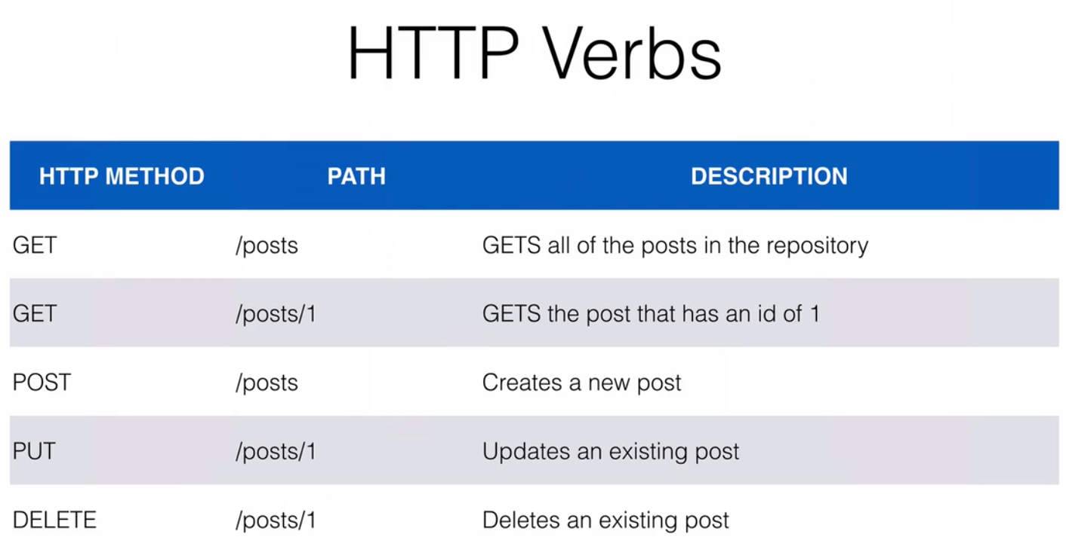

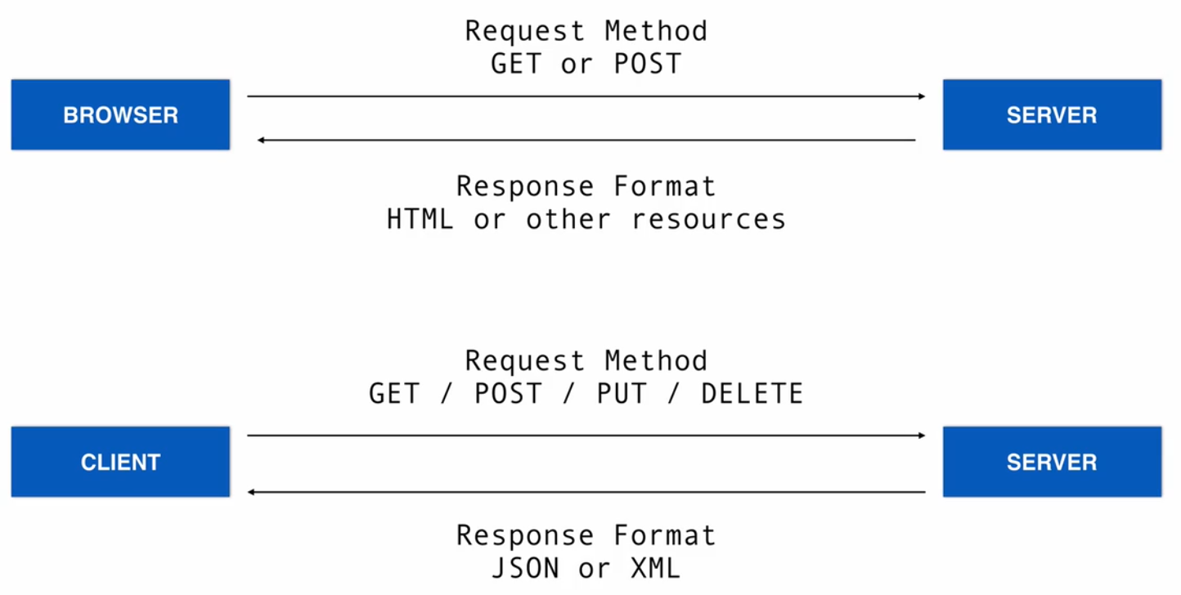

HTPP STATUS CODE

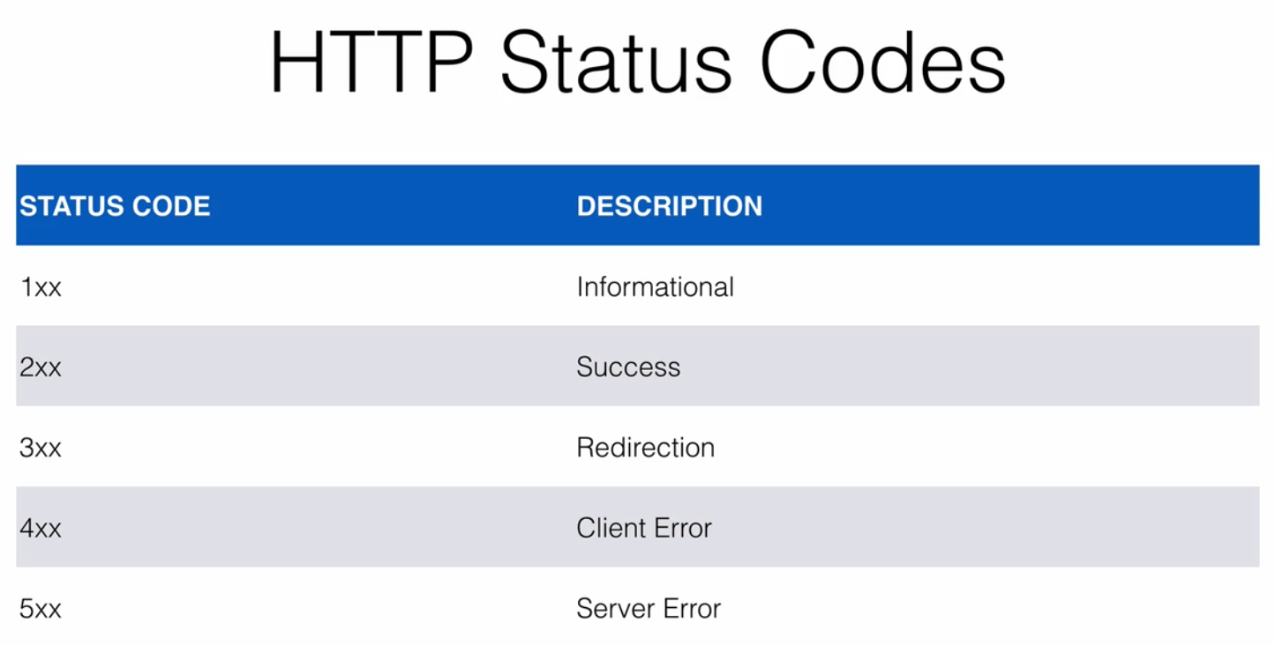

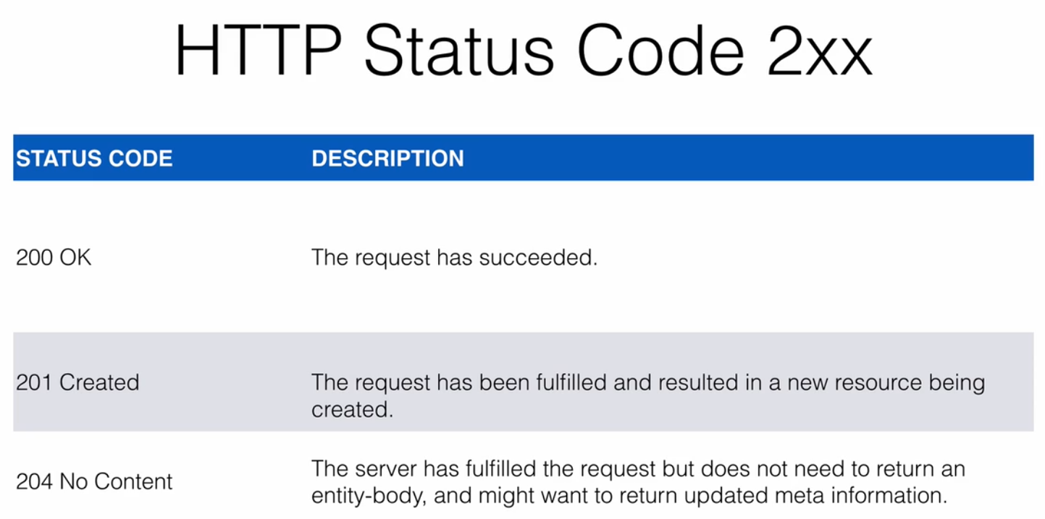

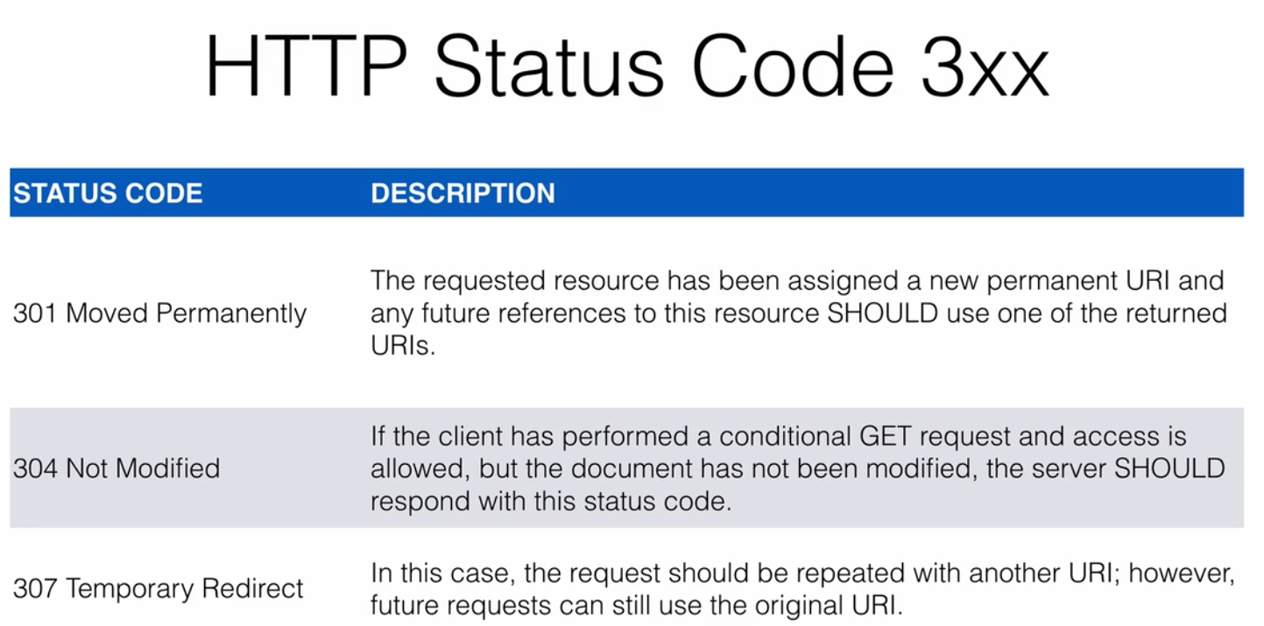

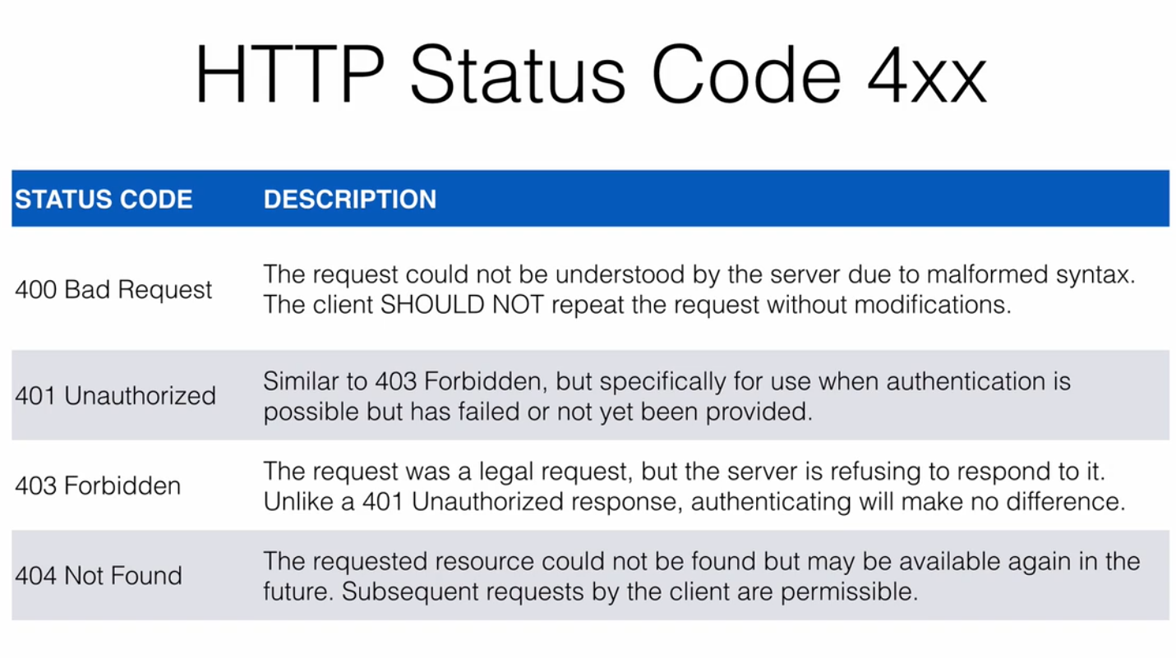

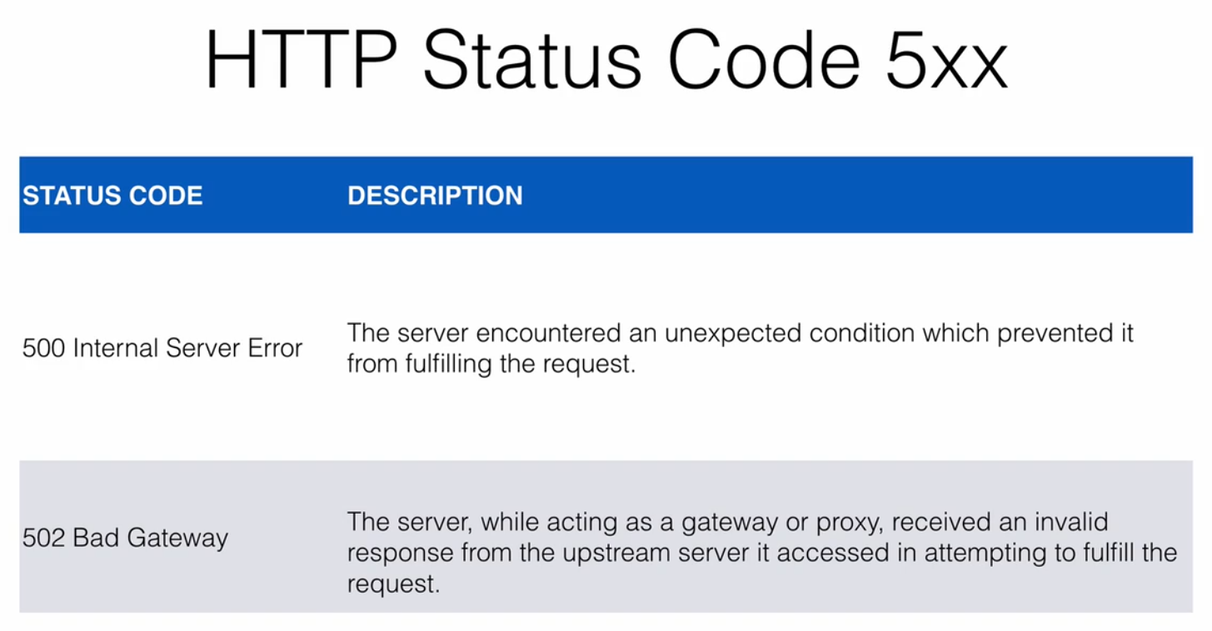

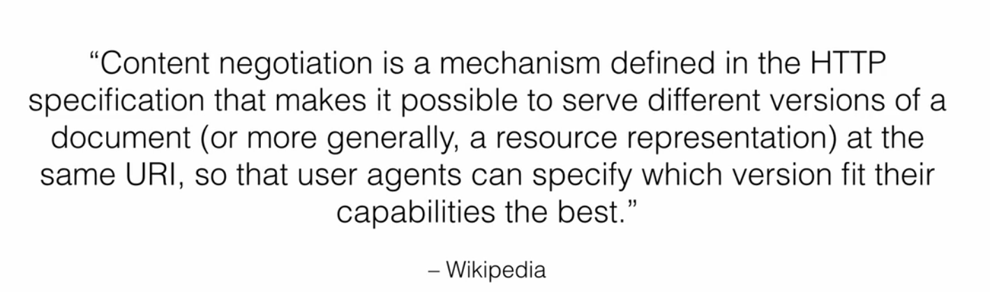

Content Negotiation

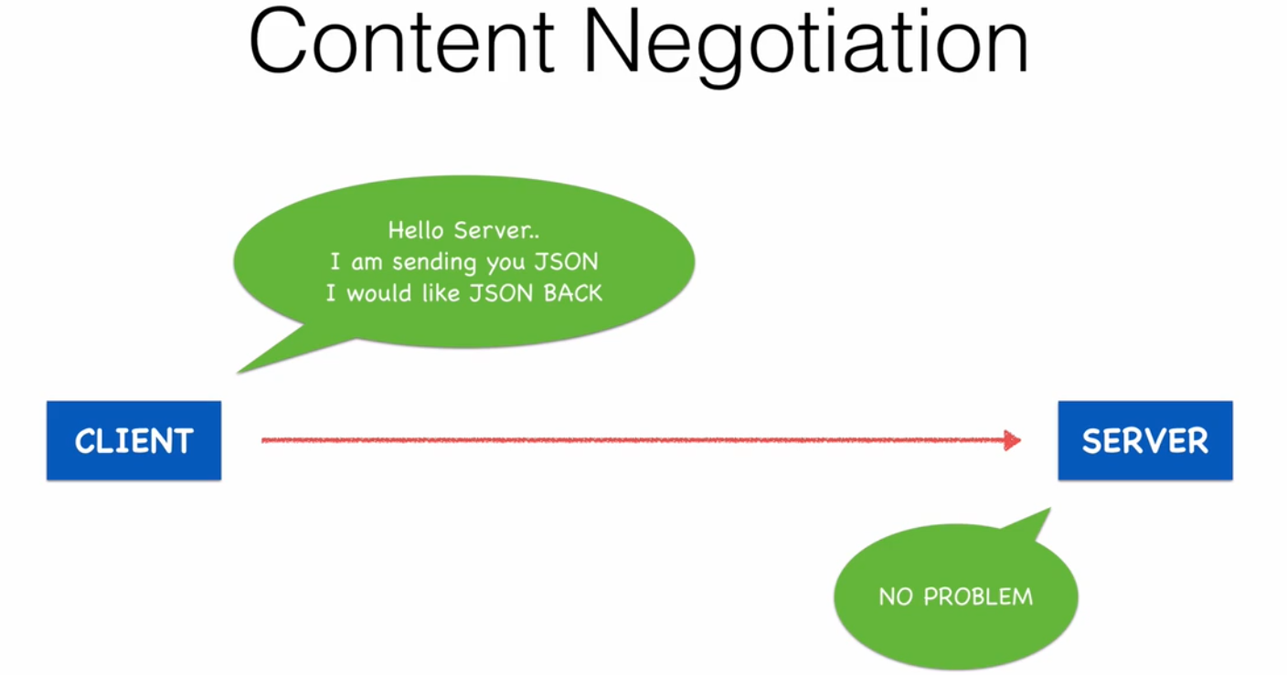

HTTP Client

-use post man

- build REST API using and Mention HTTP verbs

Exception Handling

- DataNotFoundException

public class DataNotFoundException extends RuntimeException{

public DataNotFoundException(String msg) {

super(msg);

}

}

@GetMapping("/{id}")

public BlogPost list(@PathVariable("id") int id)

{

BlogPost post=postService.read(id);

if(post==null)

{

throw new DataNotFoundException(this.getClass()+"===>Data Not found for Id:"+id ); //need to handle the exception thrown

}

return post;

}

-handling Exception and controlling its status code and response format

@ExceptionHandler(DataNotFoundException.class)

public void dataNotFoundExxception(DataNotFoundException exception,HttpServletResponse response) throws IOException

{

response.sendError(HttpStatus.NOT_FOUND.value(),exception.getMessage());

}

Spring Data Rest

Spring Data + REST = Hypermedia

What Is spring data rest?

- build on top of spring data repository and automatically export it has rest resources

- hypermedia allow clients to find functionality expose by the repository and intgerates these resources into related hypermedia base functionality automatically

- means no need create rest curd operations

- point spring data rest will get all end points for CRUD

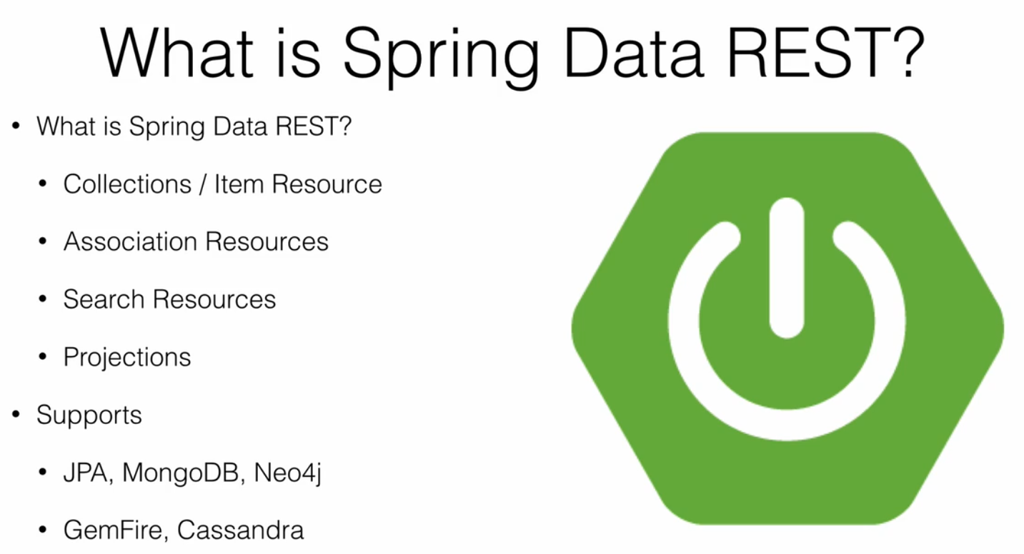

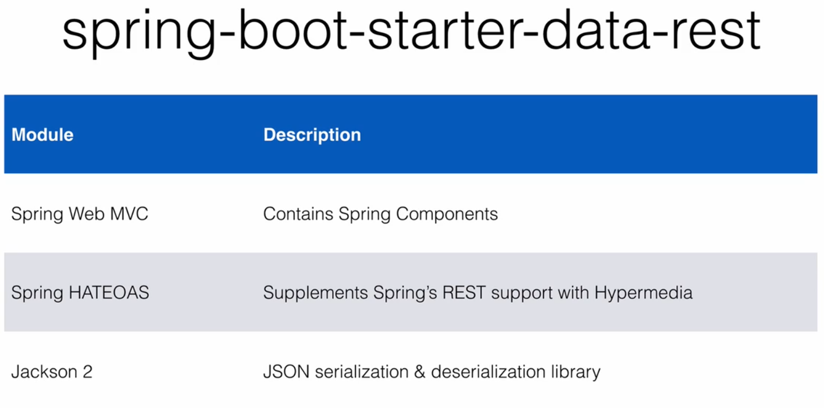

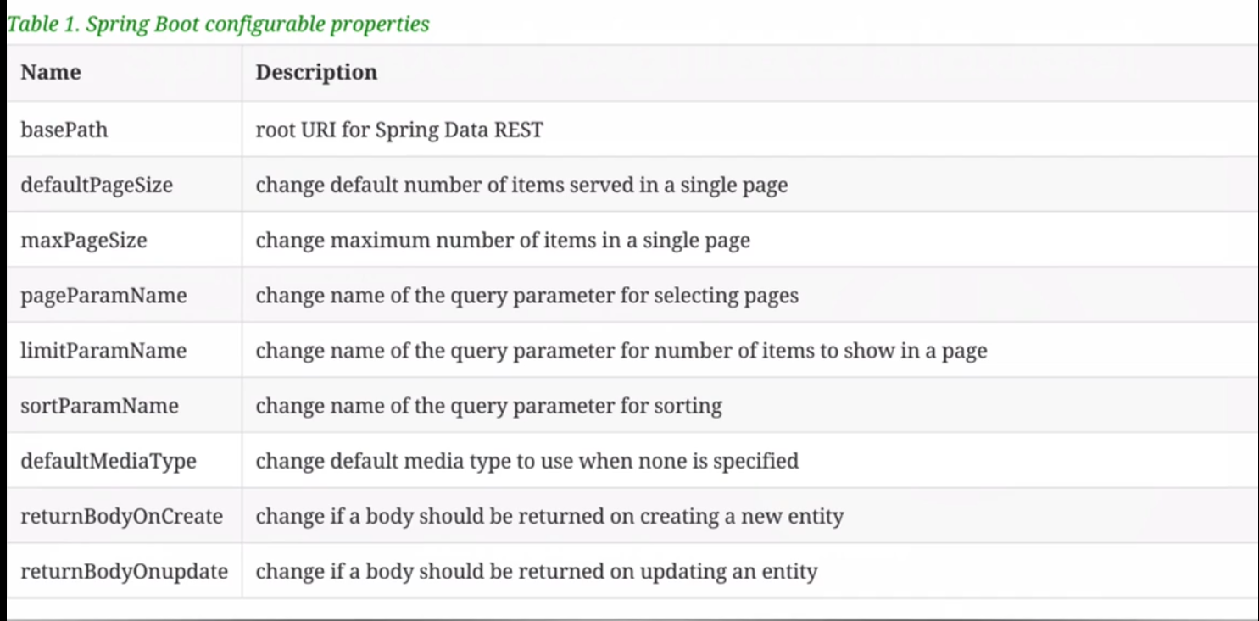

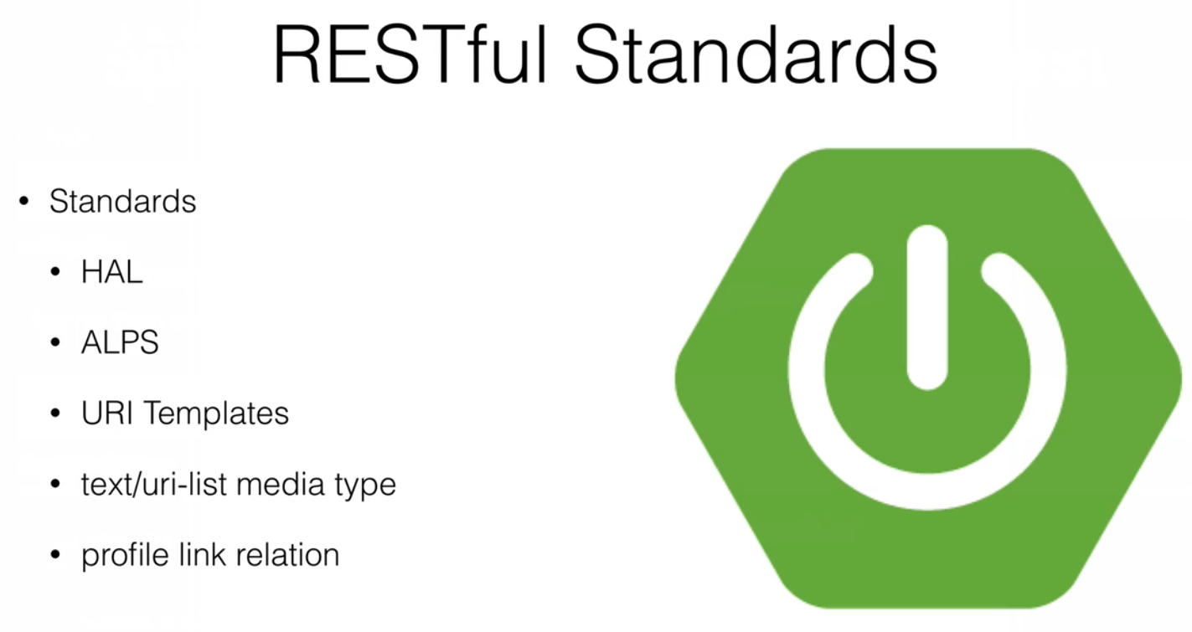 -Sprign data rest build on RESTFULL standard

-uses HAL as default media type

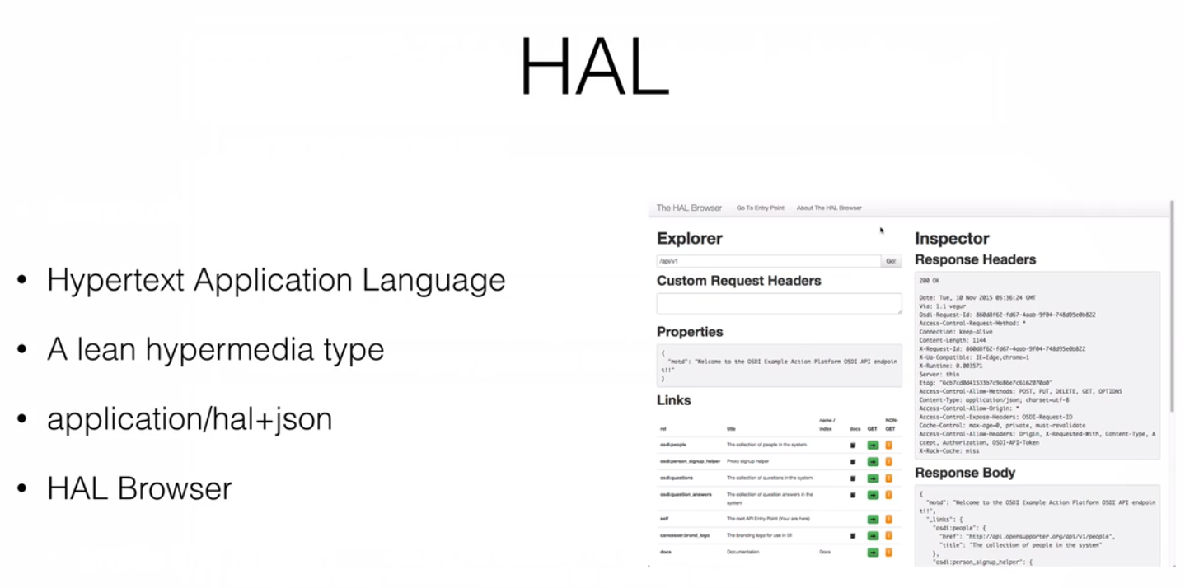

-HAL Browser can be added application by adding its dependency

- API been discoverable we can map our endpoints

-we can browse ,create and update through HAL browser

http://localhost:8080/browser/index.html#

<dependency>

<groupId>org.springframework.data</groupId>

<artifactId>spring-data-rest-hal-browser</artifactId>

</dependency>

Spring Data Rest Documentation : <https://docs.spring.io/spring-data/rest/docs/current/reference/html/#reference>

<!-- Sprind Data rest support and Hypermedia -->

<dependency>

<groupId>org.springframework.boot</groupId>

<artifactId>spring-boot-starter-data-rest</artifactId>

</dependency>

- instead of using CurdRepository we can use PagingAndSortingRepository

- which will give some other implement methods

@RepositoryRestResource(path=”blogposts”) to configure url path for custom RequestURL Mapping

- r else will bean name in pural from her URL mapping

- along with in built methods from Repository new Query method can created using JPA queries

@RepositoryRestResource(path="companys")

public interface CompanyRepostirory extends JpaRepository<Company, Integer>{

List<Company> findByCompanyNameContaining(@PathVariable("companyName") String companyName);

}

-using HAL broser we can know its application+HAL/json

- we can get Repository and its method serach methods ,profiles etc

Projections

- create a new Projection

- it will be an inter

-spring data will present the default view of Entity/domain we may need to alter the view of the model for various case

- by default dnt want to expose ID,PK amd FK

- create an interface in the same package where entity created r sub package of entity pacakage it is mandatory

- sub set of entity

-one view of model we want handle

- for that particular interface create methods getter methods required cases

@Projection(name="teaser" ,types = BlogPost.class)

public interface Teaser {

String getSlug();

String getTitle();

String getTeaser();

}

- <http://localhost:8080/companys/1?projection=teaser> : single ID based data

- [http://localhost:8080/companys?projection=teaser](http://localhost:8080/companys/1?projection=teaser) : whole data

Which will only return title , teaser, slug

@Projection(name="companyname" ,types = Company.class)

public interface CompanyName {

String getCompanyName();

String getArea();

Long getPhno();

int getPincode();

}

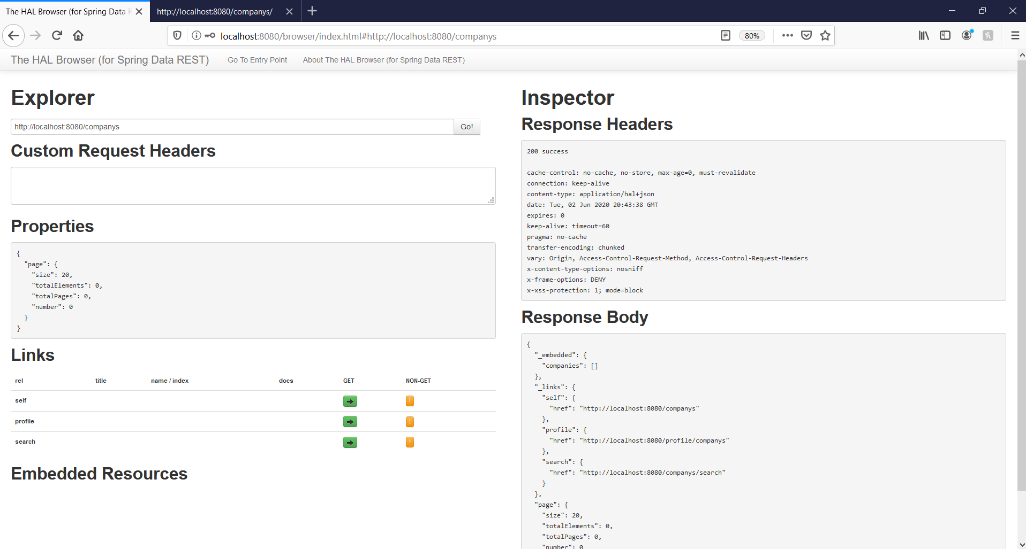

-click on do get and post data using its default form and check its response in Insepctor Response header

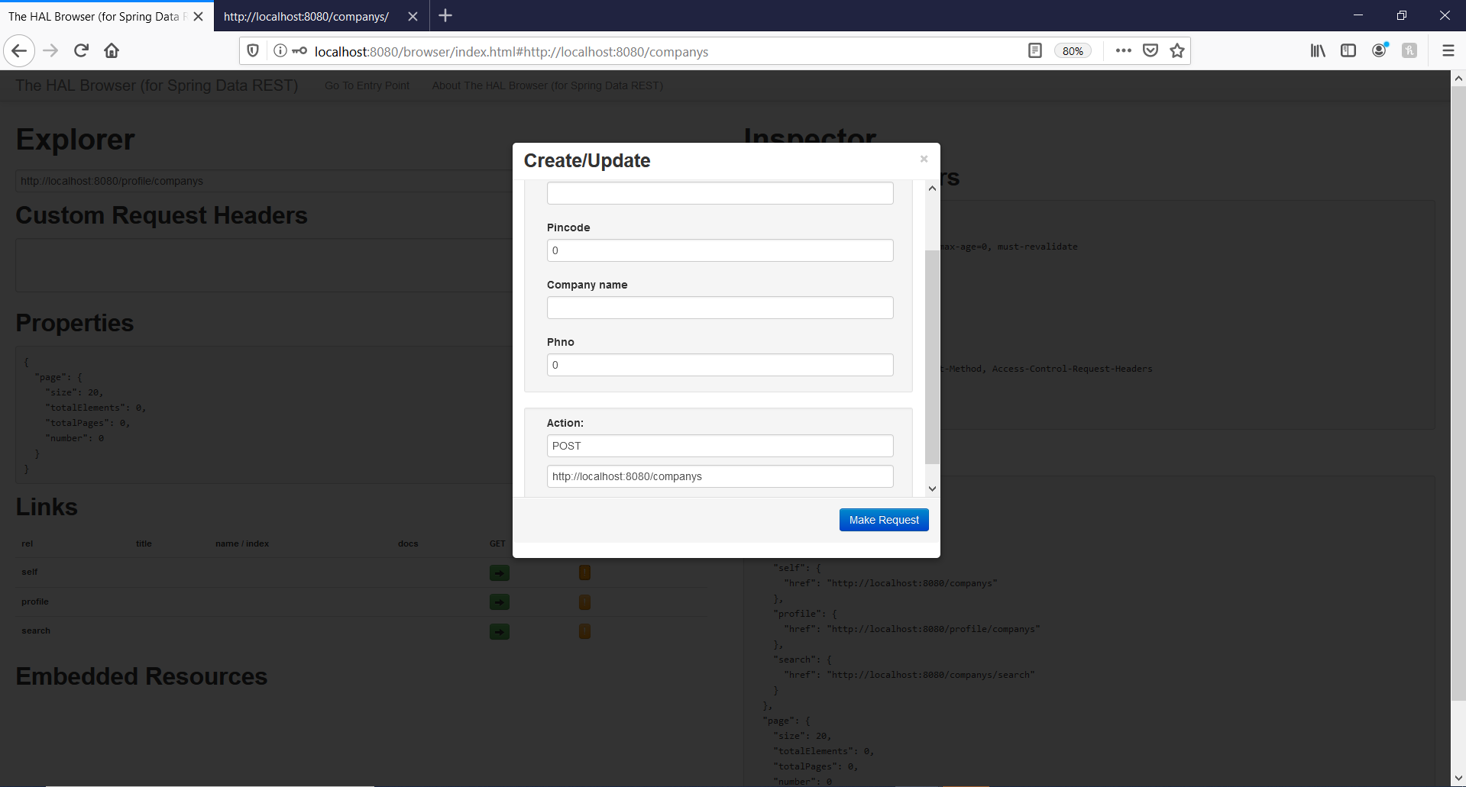

- posting problem occur for POST,PUT,DELETE in postman or HAL browser add

- add below lines in SecurityConfig to resolve that issue

.and()

.csrf().disable()

<http://localhost:8080/companys?projection=companyname>

<http://localhost:8080/companys>

<http://localhost:8080/companys/235?projection=companyname>

REST TEMPLATE

-Till create a API was concentrated now it will be consuming

- To call an REST API and get data back and map it object our system

-solution REST TEMPLATE

- just like JDBC template it helps simplfy lower level details

- Spring center class for synchronize client side http access

- it simplyfy communcation with http servers and froces RESTFULL services

<https://docs.spring.io/spring/docs/current/javadoc-api/org/springframework/web/client/RestTemplate.html>

- call local json data for testing

-getForObject using these method we can map object by json data

- create folder data in static directory whcih will be accessed by every where

- create json file in data

{

"temp":***"60"***,

"description":***"60 and cloudy"***,

"location":{

"city":***"Hassan"***,

"state":***"Karnataka"***,

"country":***"India"***

}

}

- pretend this dummy data has rest service

-http://localhost:8080/data/weather.json

- REST TEMPLATE still pending need to fix it

@RestController

public class RestTemplateDemoController {

@GetMapping("/data/consume")

public Weather getWeather()

{

RestTemplate restTemplate=new RestTemplate();

ResponseEntity<Weather> weathers= restTemplate.getForEntity("http://localhost:8080/data/weather.json", Weather.class);

if(weathers!=null)

{

weathers.getStatusCode();

weathers.getBody();

}

return weathers.getBody();

}

}

Excption :

## Global Handler

Could not extract response: no suitable HttpMessageConverter found for response type [class com.toy.joy.shop.entity.Weather] and content type [text/html;charset=UTF-8]

Spring BOOT CRUD